Slide 1: Cover
A Pharmacy Stakeholder Webinar Informational Update was held on July 25, 2018.
Slide 2: Important Reminders
Some friendly reminders:
- When dispensing a Schedule II –V controlled substance Customer ID must be shown at pickup only
- Customer ID is also required to be submitted with Gabapentin record submissions beginning on August 1st
- Social Security Numbers continue to be entered in the Customer ID field despite warnings that this is not a valid entry
Slide 3: Pharmacists Registered in MassPAT
Pharmacist Community registered in MassPAT – a total of 5,841
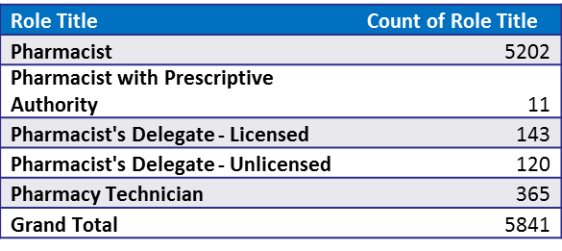

Slide 4: MassPAT Searches by Pharmacists
Pharmacist searches by Role title in CY2018,Q1 – a total of 304,509 searches
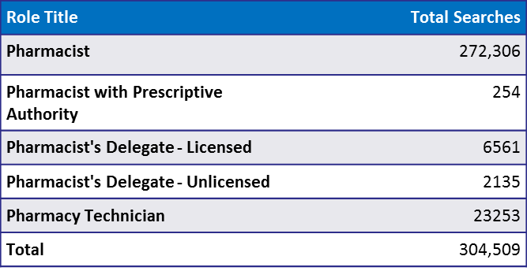

Slide 5: Awareness Campaign
An awareness campaign rolls out September 2018. The goal of the “Part of the Solution Campaign” is to encourage Massachusetts prescribers and dispensers to play an active, ongoing role in addressing the opioid crisis by utilizing one of the important tools made available to them, the Massachusetts Prescription Awareness Tool (MassPAT).
Many communications assets will be used to help convey the message including a quarterly email through the DPH database. Organizational partnerships will be used as distribution channels to key audiences. All assets and content to be housed on the dot gov platform for users to reference or gather more information on MassPAT.
Slide 6: Integration Campaign
The ability for pharmacies to integrate a patient’s MassPAT prescription history directly in their pharmacy software system is now available.
  - Once integrated, the pharmacist is no longer forced to login to a separate web application and to enter the patient’s name and DOB.
  - Instead, the Pharmacy Management System (PMS) would initiate a query to MassPAT with the pharmacist’s credentials (License Number or DEA Number), patient information (Name, DOB, Zip Code), and location information (name, address, NPI Number)
Two API versions available to pharmacies: ASAP and V5.1.
  - ASAP requires pharmacy software systems to use a style sheet to stylize the data
  - V5.1 returns a link to a pre-formatted HTML report.
Walmart pharmacies went live in MA this week and Boston Medical Center pharmacies are in the testing phase.
  - Both have also purchased NarxCare from Appriss Health which returns an enhanced report that includes a patient risk score for three categories of schedule drugs.
Slide 7: Pharmacy Software Systems
Table of Pharmacy Software Systems, the API version they’re using, and their current development status.
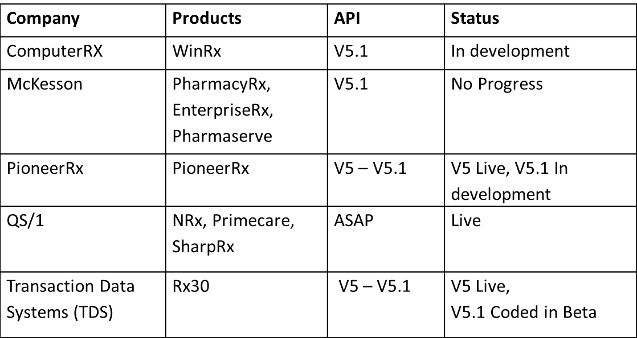

Slide 8: Pharmacy Software Systems
Table of Pharmacy Software Systems, the API version they’re using, and their current development status (continued).
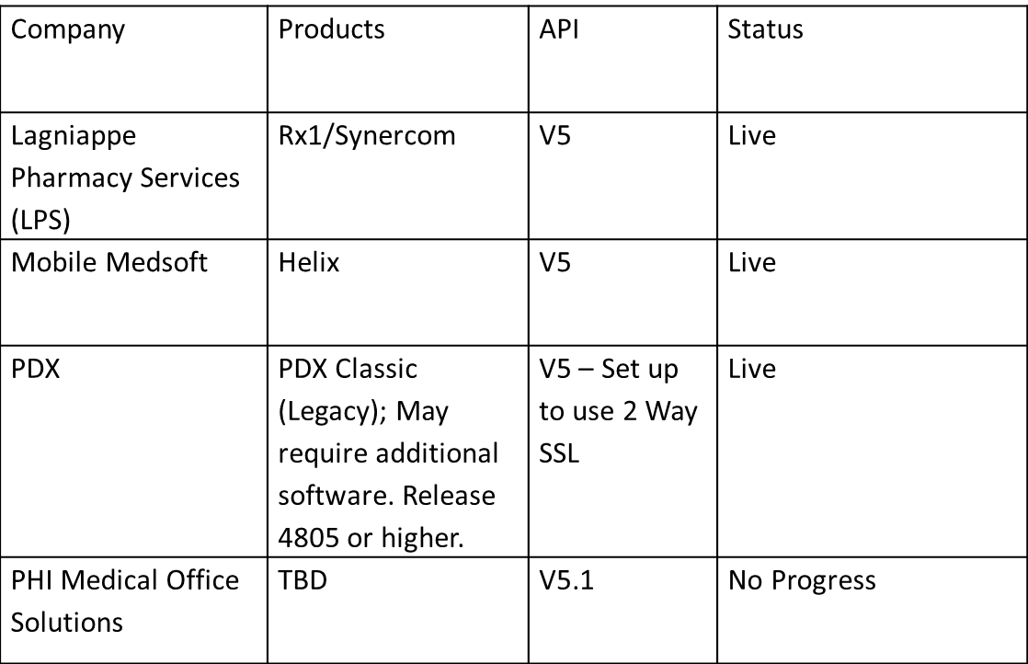

Slide 9: Integration Status
CVS has gone live in Rhode Island with V5.
Walgreens is currently in negotiations with Appriss Health.

Slide 10: Integration Update
Integration requests can be made on the EHR Integration section of our website and should only be made by authorized decision makers.
  - Questions can be addressed to PMP.EHR@state.ma.us
Pharmacies will be required to complete an Integration Request Form, Terms and Conditions, and PMP Gateway Questionnaire
Pharmacists will need to have an active MassPAT account, with a valid DEA or Professional License Number, to perform integration searches.
Only Pharmacist and Pharmacist with prescriptive authority roles are allowed via integration
Pharmacy Technicians and Pharmacy Delegates both licensed and unlicensed will not be allowed and should continue to use the MassPAT web portal.

Slide 11: Integration Update
A sample of the V5.1 report

Slide 12: NARxCHECK
A sample of the V5.1 NarxCare Report is displayed.
Narx Scores, including Narcotic, Sedative, and Stimulant scores are displayed along with an Overdose Risk Score and Additional Risk Indicators.

Slide 13: No Title
A sample of the ASAP NarxCare report is displayed. Narx Scores, including Narcotic, Sedative, and Stimulant scores are displayed.
Overall risk is displayed in graph form on the right of the report.

Slide 14: V5.1
Sample ASAP report with NarxCare as displayed by QS/1.
Narx Scores, including Narcotic, Sedative, and Stimulant scores are displayed. The Overdose Risk Score is not included.

Slide 15: Integration Update ASAP report with NarxCare
Example of interactive graph displaying all prescribers including the type of drugs they've prescribed as found on a NarxCare report.
Also displayed are Morphine Milligram Equivalents (MME) and Lorazepam Milligram Equivalents (LME) during the time period.

Slide 16: No Title
Interactive graph found on NarxCare report listing a patient’s prescribers and type of drugs prescribed to the patient over the past year.

Slide 17: No Title
Example of what displays when hovering over the interactive graph.

Slide 18: No Title
Example of typical prescription data contained within a NarxCare report.

Slide 19: Data Quality
A few of the Issues affecting the quality of the data a prescriber or pharmacist may find in a patient’s prescription history that could impact clinical judgment are:
Failure to report within 24 hours or the next business day, is getting better. Pharmacies are reporting with more regularity, but there is still some room for improvement.
Reminder: submission waiver requests for the 2018 fiscal year were due July 1st.

Slide 20 Data Quality (cont.)
Rejected prescription records with uncorrected errors will not be found by the clinician or pharmacist during a patient search, so it is very important that the errors be corrected as soon as possible.
The most common errors are:
- Missing or invalid prescriber first and last names, and DEA numbers
- Missing dispensation surrogate information-which is information pertaining to someone other than the patient picking up the prescription
- Missing patient demographic information- such as name, address, birthdate, gender.

Slide 21: Error Correction on MassPAT
Although the data submitter is notified by email that records have been rejected the records can still sit uncorrected for weeks, sometimes are never corrected, and never appear on MassPAT. Communication between a pharmacy and the data submitter (which is often a corporate submitter or the pharmacy software vendor) can be minimal and the MA pharmacy might not have any idea that there are issues and scripts that are not appearing on MassPAT.

To help with this we are introducing a new feature on MassPAT, called “Error Correction”…
Pharmacy staff who have been selected by the pharmacy and granted privileges by the PMP will now be able to easily view and correct submission errors for prescription records that have not already passed validation.

Slide 22: Error Correction Screen
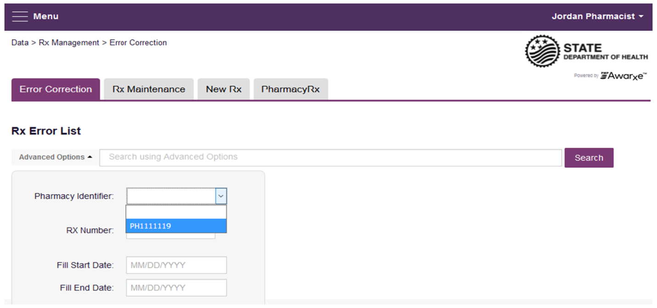

Slide 23: Rx Maintenance
For those records that were accepted and already appear on MassPAT, but contain information that needs to be corrected, we will be rolling out a feature called “Rx Maintenance”. This feature needs additional testing before we make it available, but we are excited about the prospect of giving pharmacists more power to improve the quality of the data on MassPAT. 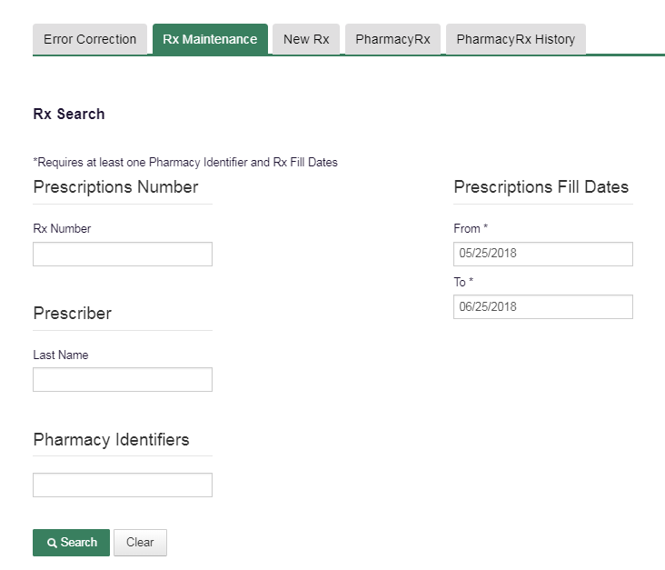

Slide 24: DEA
Over 4,000 prescriptions have been filled under expired DEA numbers so far in 2018.
We’re also seeing prescriptions being filled Under the Wrong DEA numbers:
We have gotten calls from many prescribers reporting that prescriptions, prescribed by other clinicians, have been filled erroneously under their DEA numbers. We think this may be due to pharmacists pulling up prescribers by name first instead of the DEA number.

Slide 25: DEA Issues (cont.)
These are errors that impact calculations such as multiple provider episodes, which in turn affect alerts we send to prescribers and trends we report to the public. If one pharmacy uses a valid DEA and one uses an expired DEA or wrong DEA number when filling prescriptions for a patient it looks like two different prescribers instead of one. You end up with patients appearing to see more providers than they have, and providers appearing to prescribe more or less than they actually have. Fixing these issues will greatly improve the quality of prescription data.
Slide 26: Questions?
Questions?
mapmp.dph@state.ma.us
Phone: (617) 753-7310

Slide 24:

