Data Brief
Stimulants, health disparities, and the impact of the opioid epidemic on maternal health and high risk populations

Massachusetts Department of Public Health RELEASED: March 2019

Background
In 2015, legislation responding to the opioid epidemic was passed and signed into law by Governor Charlie Baker and reauthorized in 2016. This law, referred to as Chapter 55, enabled the linkage and analysis of various data sets from agencies across state government. Led by the Massachusetts Department of Public Health (DPH), 29 groups from government, higher education, and the private sector provided information and expertise to advance Chapter 55 goals, establishing an unprecedented public-private partnership to maximize the use of administrative data to study a major public health crisis.
In 2017, a new statute M.G.L c. 111 s. 237 was promulgated to establish the Public Health Data Warehouse which authorizes the DPH Commissioner to continue the work of examining data and trends in fatal and nonfatal opioid overdoses and to address new public health topics over time.
This data brief contains highlights from the first set of analyses conducted under the Commissioner’s 2017 authority as well as a special section on emerging trends related to stimulant overdoses. It focuses on health disparities and the impact of the opioid epidemic on maternal health and high risk populations. These analyses were conducted by academic researchers and public policy analysts in collaboration with DPH. Information about this public-private partnership can be found here.

Stimulant-Related Overdose Deaths

Key Finding #1: Counts of deaths involving stimulants have increased 25% per year since 2010 and the majority of deaths involving stimulants also involve opioids. The count of deaths involving stimulants without opioids has declined by almost 7% per year since 2000.

Why is this important? While stimulant related deaths have been increasing since 2010, this increase is closely linked to the opioid overdose epidemic. These data suggest that interventions that address stimulant use alone will not be sufficient to reduce stimulant related deaths.

Key Finding #2: The rate of overdose deaths involving stimulants and opioids is higher among males than females. The rate rose by 38% per year for males from 2011 to 2016 and by 30% per year from 2010-2016 for females.

Key Finding #3: The rate of overdose deaths involving stimulants and opioids is currently highest among Hispanic residents (10.2 per 100,000). The rate among Hispanics increased by nearly 50% per year from 2012 to 2016. The rate among non-Hispanic whites increased a little over 30% per year from 2010-2015. While the annual rates were the lowest among non-Hispanic blacks, they also saw increased rates of nearly 40% per year from 2012-2016.

Why is this Important? Understanding who is at greatest risk by gender and race/ethnicity over time allows us to best focus prevention programs and treatment resources to address population-specific needs.

Polysubstance Opioid Overdoses

Key Finding #1: Among opioid-related overdose deaths with toxicology results, 389 (17%) had only opioids in toxicology. Eight hundred and eight (36%) opioid-related deaths also had stimulants in toxicology and 1,047 (47%) had opioids and another substance that was not a stimulant. Among those with opioids and stimulants, the vast majority had only cocaine present in addition to the opioid. Among those with opioids and another substance other than a stimulant, 42% had multiple substances present in addition to the opioid.

Figure 4b: Other Substance Found in Opioid-Related Overdose Deaths: 2014-2015
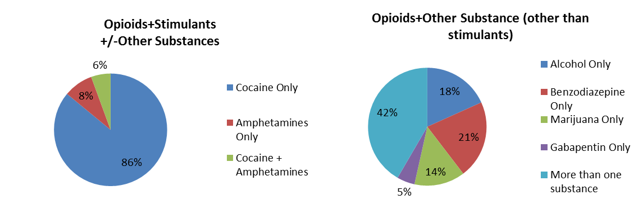
Why is this Important? Overdose prevention efforts should consider prevalent polysubstance use, including stimulants.

Key Finding #2: Older adults, persons in rural areas, and those with comorbid mental illness along with non-Hispanic black residents, and persons who experienced recent homelessness were more likely to have died with stimulants and opioids than opioids alone.

Why is this Important? Overdose prevention efforts should consider prevalent polysubstance use, including stimulants. Novel treatment and prevention programs that are tailored to these high-risk populations should be developed.

Postpartum Opioid Overdoses
Key Finding #1: Women who had an opioid overdose within one year of delivering a baby also experience an increased number of risk factors during pregnancy and at delivery, and are more likely to be enrolled in MassHealth
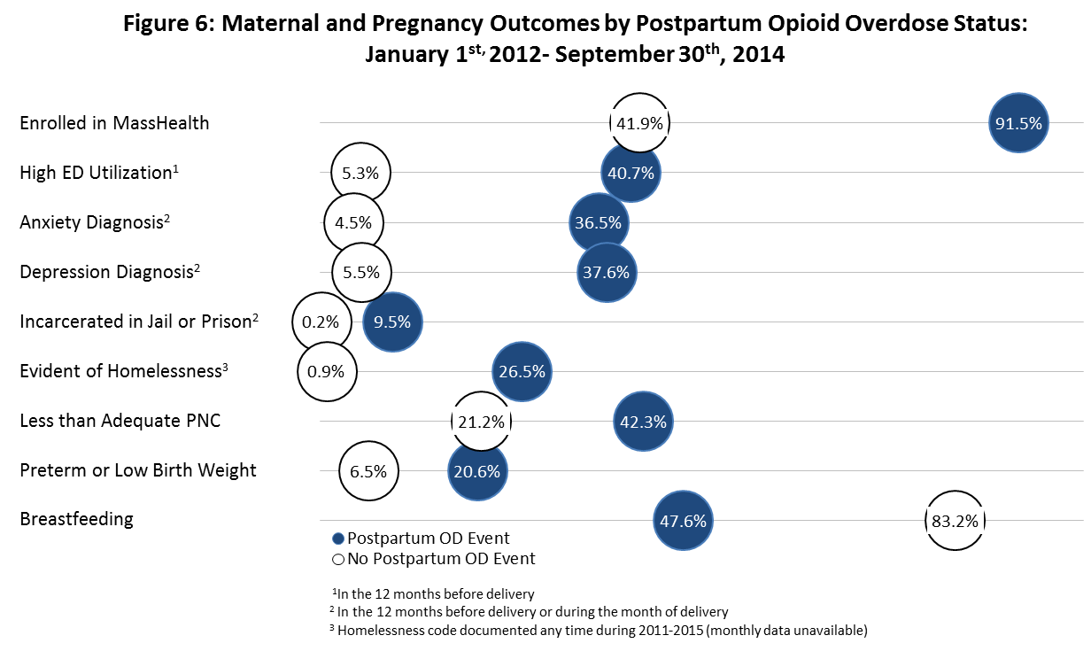
Why is this Important? Evidenced-based interventions to support women and families in the postpartum period are needed and these findings about risk factors can be used to tailor prevention programs.
Key Finding #2: The Southeast region had the highest rate of overall and postpartum overdoses. The overall opioid overdose rates were higher than postpartum opioid overdose rates for all regions, as would be expected. The difference between the postpartum and overall overdose rates was the most pronounced for the Boston region, which had a postpartum overdose rate that was about one tenth the rate of opioid overdoses overall.

Why is this Important? By reporting data at the regional or community level, communities can focus their interventions and direct resources to the areas of greatest need.

Populations at Risk: Homeless Individuals
Key Finding # 1: Among individuals with a high-likelihood of homelessness, long-term residential treatment was associated with a 48% reduction in mortality, however only 25% of these individuals were served in a long-term residential facility.

Why is this Important? These data suggest that increasing access to long-term residential services may be particularly effective for individuals experiencing homelessness.

Populations at Risk: Homeless and Criminal Justice Involved MassHealth Members
Key Finding #1: MassHealth members experiencing homelessness have significantly more non-fatal opioid overdoses than the general MassHealth population. For individuals who also have had prior engagement with the criminal justice system, the percent with non-fatal overdoses more than doubles.

Why is this Important? These findings can inform screening practices around housing stability and incarceration history to inform services and service referrals.

Key Finding #2: The 5-year average MassHealth payments were substantially higher among those who had an opioid overdose compared with those who did not. Payments were the highest for those experiencing an opioid overdose who also experienced unstable housing or were criminal justice involved.
UH = Unstable housing
CJ = Criminal justice involved
Why is this Important? Assessing service utilization before and after a non-fatal overdose may help to identify possible service opportunities to reduce opioid overdoses and improve outcomes among those members with an overdose by recognizing where these service opportunities might exist in the future.

Populations at Risk: Veterans with a History of Homelessness or Incarceration

Key Finding #1: Veterans experiencing homelessness or incarceration had more access to prescribed opioids, simultaneous benzodiazepines and opioids prescriptions, and access to high dosage opioid prescriptions for an extended period than non-veterans who were homeless or incarcerated.

Why is this Important? These findings suggest that the integration of initiatives focused on improving opioid prescribing in Veterans experiencing homelessness and incarceration to improve patient safety in these populations is warranted.

Key Finding #2: Among those with a history of homelessness and/or incarceration in Massachusetts, Veterans had a 50% increased risk of nonfatal opioid overdose and 60% increased risk of fatal opioid overdose.

Why is this Important? Among already high-risk populations (those with a history of homelessness or incarceration) veteran’s status itself is associated with increased risk of fatal and nonfatal opioid overdose.

Racial and Geographic Disparities
Key Finding #1: Black residents in Massachusetts, and in Boston specifically, were less likely to receive substance use treatment following hospital-related care for opioid overdose compared with White residents.

Key Finding #2: The odds of receiving subsequent substance use treatment within 30 days following a hospital patient encounter for opioid overdose were 29% lower for Black residents throughout Massachusetts and 58% lower for Black residents of Boston than for Whites.

Why is this Important? There are likely many known and unknown explanatory factors impacting treatment access rates and observed racial/ethnic and geographic differences, including differences in the social determinants of health, which may be independent of the hospital and treatment care systems. Given the substantial racial/ethnic inequities observed in this analysis, more conscious efforts need to be made to engage and offer treatment to individuals who experience treatment gaps.

- The Inpatient Substance Use Disorder Treatment Cascade

Key Finding# 1: In the Massachusetts inpatient treatment cascade, 30% of the total person-time was spent in transitions back to inpatient detoxification following any treatment stage, and these periods leading to readmission represent periods of elevated overdose risk. The rate of overdose varies along the inpatient substance use disorder treatment cascade. The highest risk of overdose occurred in the transition period between detox treatment and post-detox, followed by the transition periods returning to detox following residential or post-detox treatment.
Figure 15: Overdose Rates Along the Cascade: 2011-2015
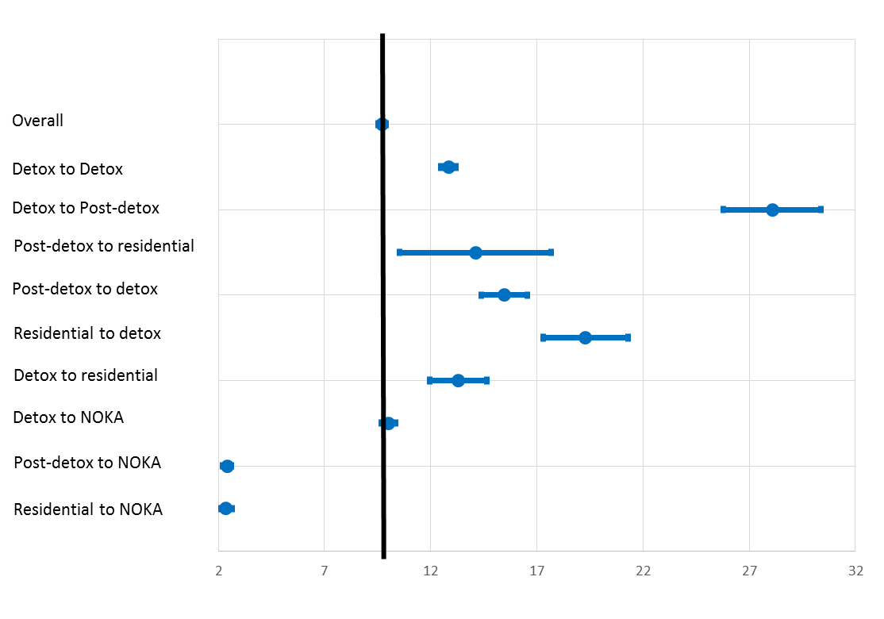
Legend: overdose rates stratified by the transition period along the treatment cascade. The black vertical line represents the overdose rate in the overall sample.
NOKA = no other known admissions.

Why is this Important? The black vertical line represents the overall overdose rate. This figure highlights the comparatively high rates of overdose at various transition points, most notable in the period between detox and post-detox. These results suggest that interventions to reduce transition times and link individuals to subsequent care quickly may be beneficial, especially among those recently exiting detoxification.

Post-Surgical Opioid Prescribing

Key Finding: Patients of high supply (those in the top 1/3 of opioid prescribing) and low supply (everyone else) medical residents have comparable injuries and demographics, but the patients of “high supply residents” receive about 20 more opioid pills after their surgeries. The patients of high supply residents consequently have different patterns of opioid use in the months after surgery.
Figure 16: Average Number of Opioid Pills Received by Patients of High and Low
Supply Medical Residents: 2011-2015
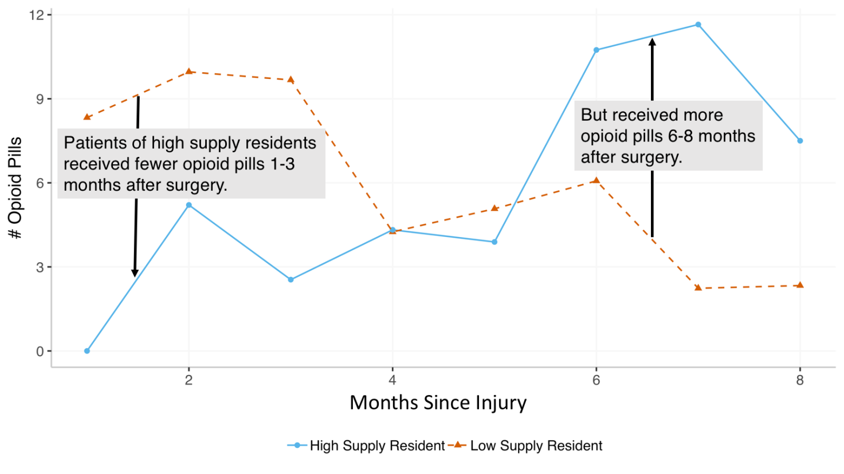
Why is this Important? The prescription quantity at discharge is crucial in determining the short-term need for re-prescription and the long-term risk of dependence for the patient. Policies that regulate the volume of opioid prescribed to the newly exposed may consequently be effective at reducing long-term dependence in a vulnerable population.

Appendix

The results in this Data Brief were drawn from analytic projects completed by partner organizations identified through DPH’s Notice of Opportunity solicitations. These projects were conducted on behalf of DPH with guidance and technical assistance from DPH staff. No funds were awarded by the Department for these projects.
Postpartum Opioid Overdoses
University of Sydney: Tim Nielsen
Virginia Commonwealth University: Mishka Terplan
Massachusetts General Hospital: Sarah Wakeman, Amy Yule, Elise Tavares, Timothy Wilens, Davida Schiff
Louisiana State University Health Sciences Center: Pooja Mehta
Populations at Risk: Homeless Individuals
Boston Medical Center: Marc Larochelle, Alex Walley, Ryan Bernstein
Boston University: Tom Byrne
Populations at Risk: Homeless and Criminal Justice Involved MassHealth Members
UMASS Medical School: Judy Savageau, Melissa Brindisi, Parag Kunte, Enid Velez, Faye Miller, Laura Sefton
MassHealth: Stephanie Brown, Adam Stoler, Peg Harvey
Populations at Risk: Veterans with a History of Homelessness or Incarceration
Edith Nourse Rogers Memorial Veterans Hospital: Guneet Jasuja, David Smelson, Dan Berlowitz, Megan McCullough, Donald Miller
Boston University: Adam Rose, Tom Byrne
Racial and Geographic Disparities
Boston Public Health Commission: Dan Dooley, Amar Mehta, Johnna Murphy, Roy Wada
Northeastern University: John Griffith
Polysubstance Opioid Overdoses
Boston Medical Center: Joshua Barocas, Jianing Wang, Marc Larochelle, Benjamin Linas, Alexander Walley
Brown University: Brandon Marshall, Curt Beckwith
The Inpatient Substance Use Disorder Treatment Cascade
Boston Medical Center: Jake Morgan, Jianing Wang, Joshua Barocas, Alexander Walley, Benjamin Linas
Boston Public Health Commission: Jennifer Jaeger
Post-Surgical Opioid Prescribing
Harvard University: Matthew Basilico, Abhiram Bhashyam, Emma Harrington, Michael McWilliams
Massachusetts General Hospital: Marilyn Heng

Inpatient treatment for substance use disorders has been standardized as a succession of steps from acute detoxification to long-term residential or “cascade”
Medical residents are qualified physicians who have passed their medical boards and who practice medicine under the direct or indirect supervision of a senior clinician

