The Commonwealth of Massachusetts
Executive Office of Health and Human Services
Department of Public Health
Bureau of Health Care Safety and Quality
67 Forest Street, Marlborough, MA 01752

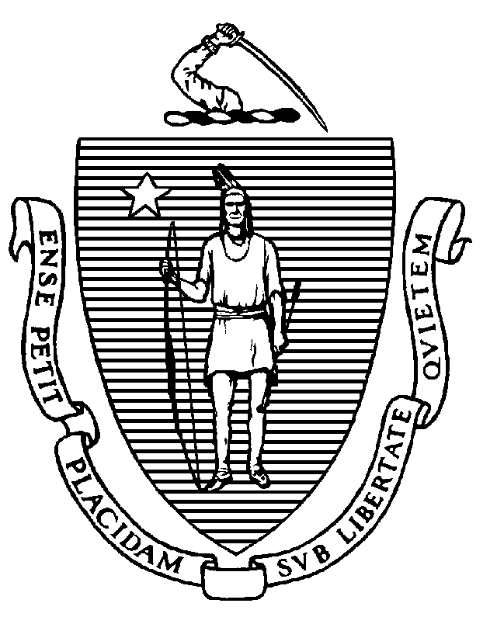

KATHLEEN E. WALSH
Secretary
ROBERT GOLDSTEIN, MD, PhD Commissioner

Tel: 617-624-6000
www.mass.gov/dph

MAURA T. HEALEY
Governor
KIMBERLEY DRISCOLL
Lieutenant Governor

Memorandum

TO: Licensed Out-of-Hospital Dialysis Units

FROM: Elizabeth D. Kelley, MPH, MBA, Director
Bureau of Health Care Safety and Quality

SUBJECT: Staffing at Out-of-Hospital Dialysis Units

DATE: May 9, 2023

This memorandum is to provide notice to licensed out-of-hospital units that the waiver of the statutory requirement for an out-of-hospital dialysis unit to have at least one direct patient care staff member to every three patients undergoing dialysis provided that the out-of-hospital dialysis unit otherwise ensures that sufficient direct care staff, who are trained in dialysis care, are available to meet the needs of patients undergoing dialysis, will remain in place until November 10, 2023, pursuant to section 68 of chapter 2 of the Acts of 2023.

“Direct Care Staff” means registered nurses, licensed practical nurses, and trained dialysis technicians who provide direct care to patients undergoing dialysis in the unit. Direct care staff may include charge nurses, but does not include the nurse manager, nurses assigned to dialysis training, or technicians assigned to dialyzer preparation or reuse, equipment maintenance, and water testing and purification.

All other statutory and regulatory staffing requirements remain in effect.

