Massachusetts Department of Public Health

MA EMS TRAINING OFFICER GUIDE 2024

Duties and Responsibilities

Training officers play a critical role in supporting EMS agency staff’s EMS certifications and recertifications.

- EMTs may affiliate with an EMS agency that provides pre-hospital medical care, or may renew as “Inactive” (with NREMT certification) or “Unaffiliated” (without NREMT certification; MA only)

- Training Officers maintain agency rosters on NREMT.org and facilitate the submission, review, and approval of the required Continuing Education for recertification

- Each EMS agency listed on NREMT.org must have at least two designated Training Officers listed on the site

  - An EMS agency is defined as a service actively engaged in ambulance/rescue service or health/patient care activity

  - At least one Training Officer must be currently certified by the Massachusetts Department of Public Health (Department or OEMS) as an EMT (at any level); and

  - At least one Training Officer must be a staff member of the agency. An additional Training Officer may be a member of the agency or may be a third-party vendor or a member of another ambulance service

  - EMS personnel with or without National Registry of EMTs (NREMT) certification use NREMT.org

- Although Training Officers play a large role, maintaining EMT certification is ultimately the individual EMT’s responsibility

The Training Officers shall, at a minimum, be responsible for the following related to the Department-designated continuing education tracking website, NREMT.org:

- Maintaining the EMS agency’s demographic information
Recertification: Overview

- Reviewing and approving affiliation requests for all levels of EMTs and maintaining an accurate roster of affiliated and due to recertify EMTs

- Reviewing submitted continuing education for accuracy based on proper documentation, either a properly completed MA OEMS roster or a certificate of completion

- Training Officers are required to ensure affiliated EMTs upload/import all supporting documentation to NREMT.org
  - EMS agencies must retain access to course completion documentation for affiliated EMTs for a minimum of 5 years following expiration of
certification
- NOTE: A Training Officer may not approve their own continuing education packet for recertification and/or skills. Another Training Officer with the agency must review and approve

- Training Officers ensure current NREMT Advanced EMTs and EMT Paramedics receive Medical Director approval of skills

Recertification: Two Steps to Recertify (Step A)

There are 2 required steps on 2 different websites to be completed in order to recertify.

Step A: Training (Education) Profile on NREMT.org

  - All EMTs, with or without NREMT certification, must track, assign, upload/import course completion documentation, and submit the education on NREMT.org to be approved by a Training Officer

  - Without application submission and Training Officer approval, an EMT will not recertify

  - EMTs pay NREMT application fees of $25-$32 (based on level)
  - Prior to Training Profile (Step A) submission, EMTs must ensure all education is completed and meets requirements

  - Late application submissions
    - After March 31, late application accepted with $50 late fee, must be received before April 30
    - Applications submitted, but not approved by the Training Officer, before April 1 will not be charged a late fee
    - All applications must be approved by April 30 (final deadline)

Recertification: Two Steps to Recertify (Step B)

Step B: State Application on eLicensing

  - eLicensing website on https://madph.mylicense.com/eGov

  - The state application and fee is required for recertification for all MA EMT levels. EMTs will update address, answer compliance questions, and submit the non-refundable $125 state recertification fee

  - Both Step A and Step B must be completed in order to recertify. Both NREMT.org and eLicensing will show an updated expiration date upon successful recertification

  - After an updated expiration date is visible on the eLicensing website, a new MA EMS certification card is mailed out the following week. EMTs generally receive their physical card within 10 to 14 business days.

  - EMTs do not need to carry their printed card when staffing an ambulance, if they are able to show their certification status on https://madph.mylicense.com/verification/

Recertification: Late Recertification for Step B

Step B: State Recertification Application

  - The deadline to submit the State Application without a $50 late fee is March 31.
    - After March 31, if an EMT has not recertified, their certification has expired and they may not staff an ambulance.

  - After April 1, if an EMT has successfully completed and documented the Continuing Education requirement, with an updated expiration date on NREMT.org, they may renew late with a $50 late fee, for up to 2 years from their expiration date.

Agency Affiliation Roster

  - EMTs must affiliate with an approved agency in order for their Training Officer to review and
approve their continuing education
    - EMTs must request affiliation to appear on your NREMT.org agency roster. On the EMT’s NREMT dashboard, they select “Manage Affiliations” and have them select your
agency. After they request affiliation, you go
into your “Affiliation Requests” tab to approve the affiliation.

  - After affiliation is approved, contact the EMT (email preferable for documentation purposes) regarding information on their recertification requirements
  - The agency roster shows who is affiliated with your agency, their level, and expiration year
    - Those with NREMT certification may have a different expiration date than their actual MA EMS certification (Look for One Year Alignment on FAQ page for details)
    - Verify state certification expiration dates on https://madph.mylicense.com/verification/

  - Select an EMT on the roster to “View Education Record” and “View Recert Progress” to see what education the EMT has uploaded (View Education Record) and what categories they have assigned said courses to (View Recert Progress)
    - View “Application Status” to see if the individual has submitted

Recertification: Agency Affiliation and Rosters

Be sure to keep accurate rosters; adding new employees when they are onboarded and removing those who depart

Review Approval

  - From your Training Officer role, education can be reviewed from either the “Roster” or “Verification” views
Recertification: Review and Approval on NREMT.org
  - Review the continuing education to ensure:
    - All courses have either a Commission on Accreditation for Pre-Hospital Continuing Education (CAPCE) or OEMS
approval
    - Courses were taken within the EMT’s “Recert Cycle”
    - All NCCR content requirements were met
      - Ensure courses are assigned to the correct sub-topics
    - LCCR and ICCR hour requirements are met

  - Submitted applications appear in the “Verification” tab
    - EMTs should ensure all education is completed and meets requirements before submitting the Training Profile (Step A).

  - Training Officers should retain or have access to course completion documentation for all affiliated EMTs, prior to approving education
    - Training Officer, per NREMT policy, can assign courses, but cannot upload/import the course completion
documentation. Uploading course completion documentation is the EMTs’ responsibility
- After education is reviewed, select “Approve” on the Verification tab before or after EMT submission
  - If corrections are needed, select “Deny” on a submitted application in order to allow the EMT to make updates as needed
  - After updates are made, the EMT must resubmit their application. No additional NREMT fee required

- Once approved, an updated expiration date will appear on NREMT.org for the EMT. An updated expiration date on NREMT.org does not indicate successful state recertification.

- After education is submitted and approved, instruct the EMT to complete the State Application and fee on the eLicensing website at https://madph.mylicense.com/eGov

- Once an updated expiration date is visible on https://madph.mylicense.com/eGov, the EMT has successfully recertified
  - Training officers can confirm on the online verification site at https://madph.mylicense.com/verification/

  - The NREMT and OEMS may audit any recertification education up to 5 years after recertification. An audited individual will be notified of their status. Compliance and successful completion of the audit is the responsibility of the individual selected for Audit
Recertification: Audit Policy
    - Audits may be performed based on computerized random sampling, for cause, or to ensure compliance with recertification procedures
  - During an audit, the EMT must provide documentation of all education claimed on the recertification application (Training Profile)
  - For those with National Registry certification, once their Training Profiles are submitted and if selected for Audit, if the EMT is missing education, the National Registry may not allow the opportunity to take additional education and the EMT may need to recertify by exam. Please refer to NREMT policies or contact them for details
  - For those without National Registry certification (MA only), if selected for Audit, please contact OEMS for specific guidance

EMTs should ensure all education is completed and meets
requirements, before submitting the Training Profile (Step A).

Recertification Guide for EMTs

Recertification Step A: Training Profile (First Step)
1.
Need help with Step A? Start with your agency’s Training Officer; if more help is required contact the NREMT at support@nremt.org or 614-888-4484

- Log into your NREMT account through NREMT.org.
  - All EMTs, with or without NREMT certification, use NREMT.org tosubmit their Training Profile (education)
- Affiliate with your EMS agency (employer).
  - Find your EMS agency under the "Agency Affiliations" on your Dashboard
  - If you are unaffiliated (not working asan EMT and do not hold NREMT certification):
Select "Unaffiliated - Region#" based on the region in which you live (more info available on https://www.mass.gov/how-to/renew-your-emt-advanced-emt-or-paramedic-certification)

- Enter all required continuing education hours.
  - Hours can be used if completed within this Recertification Cycle (“Recert Cycle”) and must have CAPCE or Massachusetts Department of Public Health (“Department”) approval. Your Recert Cycle is visible on your NREMT.org dashboard.

- Pay for Training Profile for Training Officer (TO) review and approval.
  - Submit your Training Profile & associated fee electronically using the Department designated site (NREMT.org).
  - PLEASE REMEMBER TO CLICK THE “SUBMIT” BUTTON ON YOUR TRAINING PROFILE.
  - Work with your TO for profile review and submission of continuing education. Your EMS agency TO will review your Training Profile for accuracy and document the proficiency of your skills (if applicable).
  - Submission Fee: $25 (Basic), $26 (Advanced), $32 (Paramedic)
  - DO NOT FORGET TO COMPLETE STEP B.

2. Recertification Step B: State Application (Second Step)
Need help with Step B? Contact the eLicensing Help Desk at 617-973-0935 or elicensing.helpdesk@state.ma.us

- Log into your state recertification application.
  - https://madph.mylicense.com/eGov

- Review and pay state recertification fee.
  - Review your information for accuracy, answer questions, and UPDATE CONTACT INFORMATION.
  - Submission Fee: $125

Submit your state application by March 31, 2024.
  - Once all the steps are complete, your application will be processed within 2 to 5 business days. You can check your recertification status on the eLicensing website. Cards are printed weekly and may take 10 business days to arrive. Electronic verification of certification is sufficient for staffing an ambulance.

IMPORTANT REMINDERS:
  - YOUR EMT CERTIFICATION IS NOT RENEWED UNTIL BOTH STEPS A AND B ARE COMPLETE!
  - As you approach the expiration of your EMT certification, be sure to login to eLicensing to ensure it has renewed!
  - Once you see you have March 31, 2026 expiration on eLicensing, NOT NREMT.org, you have
successfully recertified. Check your status at: https://madph.mylicense.com/eGov

Massachusetts Department of Public Health | mass.gov/dph 10

Recertification Timeline

TIMELINE
VARIES | OCTOBER 1, 2023 | FEBRUARY 15, 2024 | MARCH 31, 2024 | APRIL 30, 2024
Check your NREMT.org  dashboard for  Recert Cycle | Training profile (Step A) and State Application (Step B) open for  submission and online payment. | Recommended Recertification Completion Date.  Submitting early increases opportunity to resolve any issues. | LAST DAY to complete continuing education. Last day to submit recertification application on NREMT.org and eLicensing without penalty.  After midnight, if you have not  recertified, you cannot staff an ambulance! | LAST DAY to receive Training Officer and/or Medical Director sign-off (if applicable) on NREMT.org (Step A).  Late Fees apply if submitted after March 31, 2024:  NREMT $50  MA $50

Continuing Education: Proper Documentation (MA OEMS Approval)

    - OEMS Course completion certificates must include the following (must be legible in ink or typed):
      - Attendee’s full name as it appears on their certification card; and
      - Course instructor’s full name and signature; and
      - Date of course completion and if applicable, dates of all course sessions; and
      - Course hours; and
      - Which portion of the course, if any, meets any of the National Continued Competency Requirements (NCCR) for the specific level of EMS personnel and which NCCR version it follows; and
      - OEMS Continuing Education Approval Number

    - More information can be found in Administrative Requirement 2-212 available on our website at https://www.mass.gov/lists/oems-administrative-requirements

Continuing Education: Proper Documentation (CAPCE Approval)

    - The following must appear on all CAPCE certificates
      - Name of CE EMT and CE EMT number assigned by CAPCE
      - Participant's name
      - Activity title
      - Date(s) of activity
      - Location of activity (traditional classroom courses only)
      - Number and category of CEH
      - CAPCE activity number
      - Name and signature of the program coordinator
      - Participant’s license/certification number
      - Participant's state of licensure/certification
      - Participant's NREMT number (if applicable)
      - Name of EMS medical director
      - For full course completion requirements, please visit CAPCE

The NCCR makes up 50% of the required Continuing Education for recertification. The NCCR is the only category with required course content. The national category requirements are determined by the NREMT Board of Directors based data and input from EMS researchers, EMS physician, and EMS EMT stakeholders

    - The NCCR is made up of 5 categories with required sub-topics for each
Continuing Education: National Continued Competency Requirement (NCCR)
      - Airway/Respiration/Ventilation
      - Cardiovascular
      - Trauma
      - Medical
      - Operations
        - Example: EMT Basic -
Airway/Respiration/Ventilation – 1.5 hours
          - Sub-topics
            - Ventilation
            - Oxygenation
    - NCCR syllabus, content topics, and required hours for each can be located on NREMT.org

    - Required hours and sub-topics for each increase for Advanced and Paramedic certifications

    - All content areas and hours must be met

    - All the continuing education hours for the NCCR may be done through distributive education (DE)

    - Often NCCR courses are offered in “bundles” over the course of a few days. Bundles cover all content topics as opposed to individual modules for each topic

LCCR ICCR

    - The Local Course Competency Requirement
Continuing Education: Local and Individual Continued Competency Requirement (LCCR/ICCR)
(LCCR) makes up 25% of the required Continuing Education for recertification. While there is no required course content for the LCCR, agency-
level administrators (for example Medical
Directors and Training Officers) may require specific courses for the LCCR

    - All the continuing education hours for the LCCR may be completed through distributive education
    - The Individual Course Competency Requirement (ICCR) makes up 25% of the required Continuing Education for recertification. EMTs may choose their own electives for the ICCR

    - All the continuing education hours for the ICCR may be completed through distributive education

- In person; single occurrence
Continuing Education: Types of ConEd
  - T1 (OEMS), F1 (CAPCE)
    - “In-person” course with a single occurrence (may be a course made up of single or multiple days)

- In person; repeated occurrences
  - T2 (OEMS), F2 (CAPCE)
    - A course sponsor is responsible for notifying the applicable Regional EMS Council office of their intention of using the existing OEMS course approval number with the date and time via email in advance

- Pre-approved Department-issued ConEd course approval
  - T4 (OEMS), No CAPCE
    - For standardized courses with set curricula
    - This area is limited to widely distributed courses with consistent content and evaluation tools developed by a central organization (example: FEMA-NIMS: IS-**)
    - Must notify MA Regional EMS Council before holding T4 courses
  - Please see chart in Administrative Requirement 2-212
(III) for the full listing of courses
- Distributive Education (DE) course
  - T3 (OEMS), F3 (CAPCE)
    - DE courses are online, self-paced courses without a live instructor
    - All DE course restrictions have been lifted. All continuing education may be completed using DE courses

- Virtual Instructor Lead Training (VILT)
  - T5 (OEMS), F5 (CAPCE)
    - VILT courses are online with a live instructor
    - VILT courses are considered of equal value to in-person courses

OEMS cannot recommend any specific courses, but does have resources to help EMTs find a course sponsor offering courses. We recommend that EMTs ask the entity they plan on taking the class with, if they have Massachusetts OEMS continuing education approval as documented by an OEMS or CAPCE approval number

- OEMS maintains a list of the (close to 60) EMT programs on our website. This list is interactive and will link EMTs to the Accredited Training Institutions’ webpages which may list the courses available. You can find the full listing here: https://www.mass.gov/service-details/find-an- accredited-emt-training-institution
Continuing Education: Where to Find Courses

- Reach out to a local hospital, EMS, or Fire agency. Many of these entities offer EMS continuing education and may allow non-employees to attend
- Reach out to the local Regional EMS Council. On behalf of OEMS, the local Regional EMS Council is the entity which reviews and approves all in-person continuing education in their respective areas, and they might be able to recommend some options. EMTs can find the list of
Regional EMS Councils here: https://www.mass.gov/service-details/ems-regions-in- Massachusetts

- CAPCE maintains a list of approved course sponsors (and vendors), available at http://capce.org/Home/FindCourse

Recertify by Exam: With NREMT Certification

If an EMT with NREMT certification wishes to “Recertify by Exam,” they will complete a cognitive (written) exam which will meet their continuing education requirements (Step A)
  - Log in to their NREMT.org account and select the role “My Certification.” Complete a Recertification By Exam application and pay the exam fee. Contact NREMT for specific/updated instructions
    - After 24-48 hours, login to their NREMT account and print their Authorization to Test (ATT) letter. Follow the directions in the letter to schedule an exam
    - Beginning April 1, one year prior to expiration, they may make one attempt to pass the exam. Upon successful completion of the exam, a cognitive competency by exam form will become available through their NREMT account
    - Return the completed cognitive competency by exam form by March 31 with signatures and supporting documentation. All other recertification requirements (including criminal conviction statement, verification of skills, etc.) must still be met and verified
    - If unsuccessful on the exam, there is no impact on their MA EMS certification, however, they must complete and document Continuing Education in order to recertify
    - After they successfully complete their cognitive exam and renew their NREMT (Step A), they must still complete the state application and fee (Step B) on the eLicensing website at https://madph.mylicense.com/eGov

Recertify by Exam: Without NREMT (MA Only) 1 of 2

If a MA EMT, without NREMT certification (MA EMS only) wishes to “Recert by Exam,” they will need to obtain NREMT certification as a current state certified EMT, by completing continuing education, a cognitive, and psychomotor exam
- Log in to their NREMT account on www.nremt.org. Select the “Candidate” role from the drop-down box
  - Click on “Create Certification Application”

- Complete and submit the NCCR continuing education requirement for their level within the past two years

- Complete a NREMT cognitive exam
  - After the EMT applies to the NREMT with their NCCR documentation, they will receive instructions and permission to take the NREMT cognitive exam

- Complete a psychomotor requirement
  - EMT Basic: Complete a psychomotor skills verification.
    - The EMT will need the appropriate paperwork and skill sheets emailed to him/her from the NREMT or they can find the forms on our website at https://www.mass.gov/service-details/verify-psychomotor-skills-for-nremt-certification
    - Those skills sheets will need to be completed and signed by his/her affiliated agency’s Training Officer or I/C at any Department-accredited EMT training institution (ATI)
    - The EMT will need to complete any further steps required by the NREMT. In most circumstances, the EMT will email the skills sheets to the NREMT
  - Advanced EMTs or Paramedics will need to complete the full NREMT psychomotor exam
(Continued on next slide)

Recertify by Exam: Without NREMT (MA Only) 2 of 2

- After the NCCR, cognitive, and psychomotor requirements are complete, NREMT certification will be issued
  - EMTs will need to notify OEMS of their new NREMT certification status by emailing oems.recert@mass.gov

- Once NREMT is issued and OEMS is notified, they will complete the State Recertification Application and fee (Step B) on the eLicensing website at https://madph.mylicense.com/eGov. Step B must be completed for the EMT to recertify their MA State EMS certification

Using NREMT.org: Individual EMTs

Instructions and videos are available for EMTs to navigate their Continuing Education submission on NREMT.org. EMTs can find resources at https://nremt.org/document/recertification#howdoirecertify

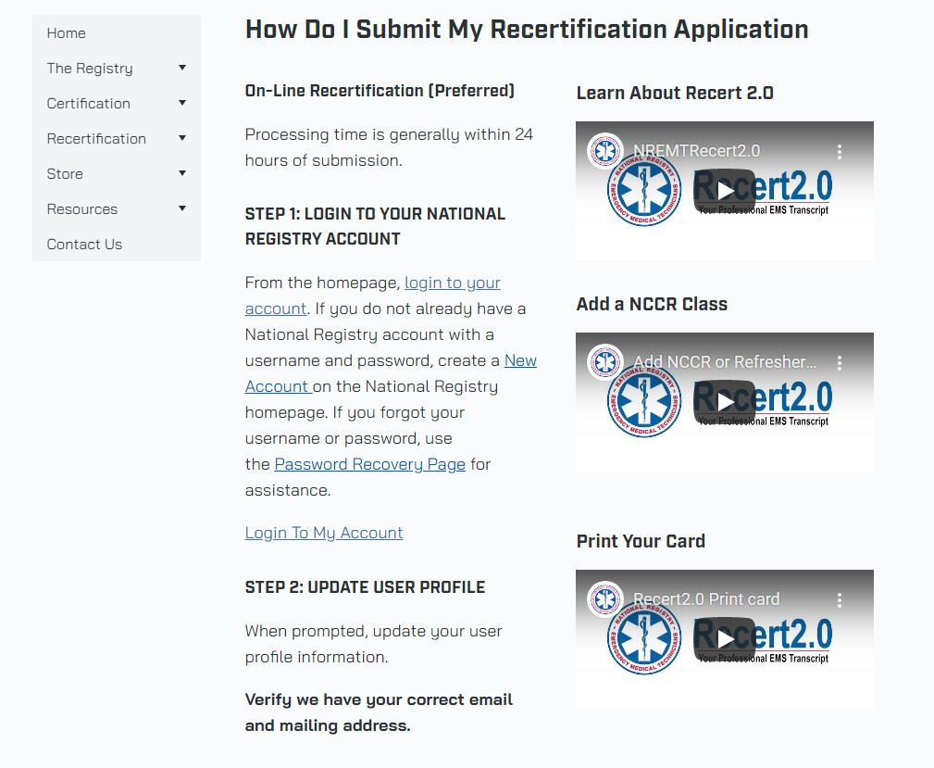
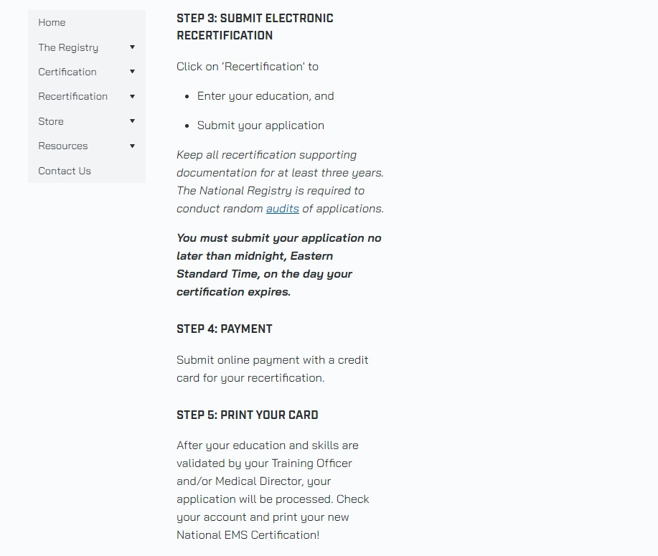

Using NREMT.org: Training Officers

Instructions and videos are available for Training Officers to navigate the NREMT website including how to create an account, affiliate, approve education, add a course for your agency, etc. Training Officers can find resources at
https://nremt.org/partners/training-officers
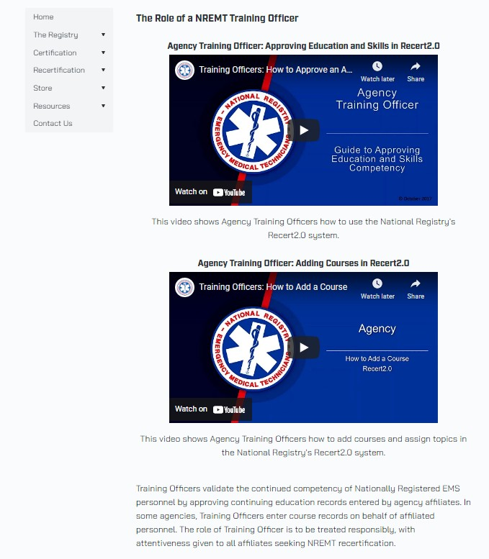
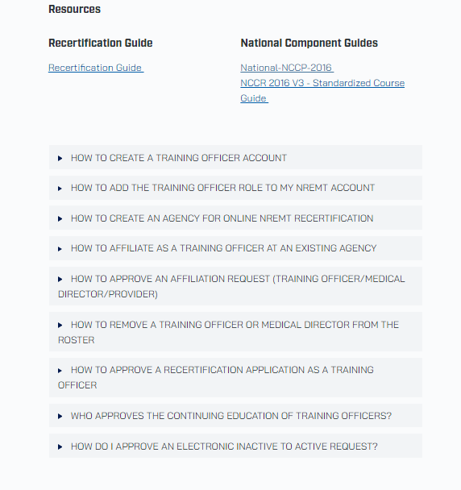

Unaffiliated Recertification

When an EMT, without NREMT certification (MA certified only), leaves an agency and is no longer working as an EMT, they can still recertify, but as an Unaffiliated EMT. Those without NREMT cannot submit as “Inactive”
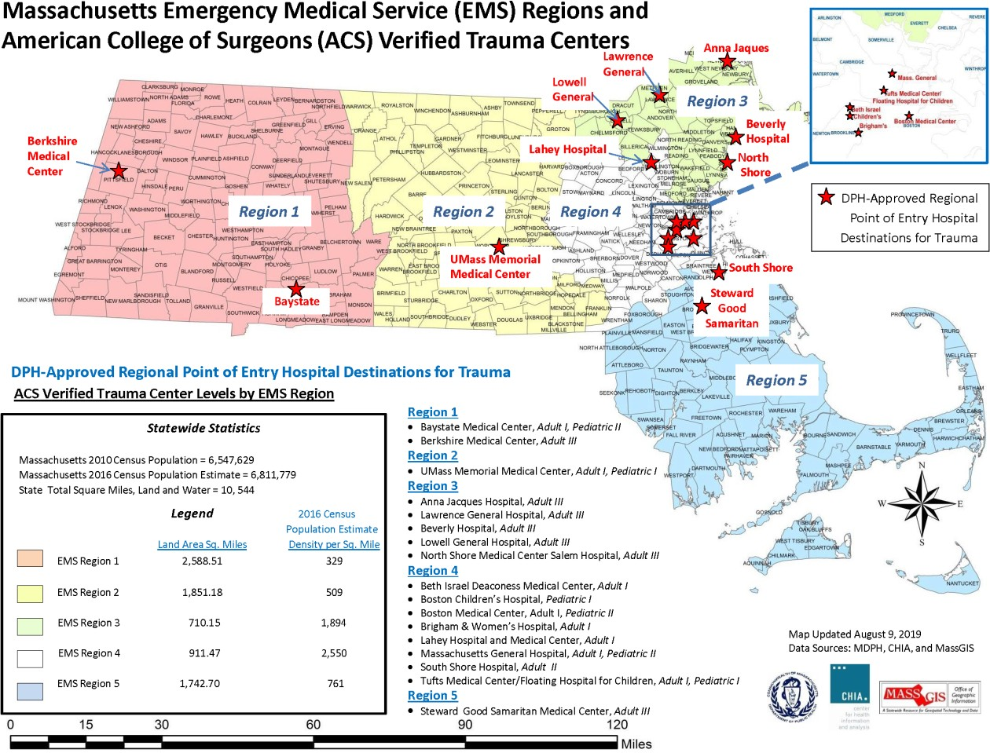
- Unaffiliated status is for MA EMTs without NREMT certification who are not currently operating as an EMT
- If an EMT is Unaffiliated, the Regional EMS Council will act as their Training Officer and review and approve their continuing education records
- They will affiliate with their region on their Certification Dashboard. Contact their region for specific instructions and training profile assistance
  - Find the regional office for their residential address at https://www.mass.gov/service-details/ems-regions-in- Massachusetts
  - Regional EMS Councils are listed as “Unaffiliated-Region [X]”
  - Unaffiliated EMTs living out of state will affiliate with “MA Unaffiliated-Out of State”
- Unaffiliated EMTs must still complete the state application and fee (Step B) upon approval of their continuing education on NREMT.org

Inactive Recertification

When an EMT, with NREMT certification, leaves an agency and is not operating as an EMT, they can still recertify but with an Inactive status. Those without NREMT cannot renew using the Inactive status (Unaffiliated).
  - An inactive status is designated for those with NREMT certification who are currently not providing patient care at their certification level. For example, inactive status may be helpful for EMS professionals who:
    - are not actively engaged in an EMS service or healthcare/patient care activity
    - are not actively treating patients at their certification level but are involved as educators, administrators or regulators
    - are unable to actively provide patient care for any variety of reasons - such as, moving, illness, pursuit of education, family responsibilities, etc.

  - The NREMT will act as the Training Officer for Inactive NREMT recertification. Registrants who wish to declare inactive status must continue to meet the NREMT continuing education recertification requirements in subsequent cycles
    - If renewing as Inactive, please contact the NREMT for specific requirements and assistance

  - Inactive EMTs must still complete the state application and fee (Step B) on the MA eLicensing website upon renewal of the NREMT certification. Inactive NREMT status has no impact on MA EMS certification

Applying for Continuing Education: Overview

EMS agencies may receive approval from OEMS to offer Continuing Education courses

  - EMS Agencies must submit:
    - Application, course outline, and supporting references
    - Application is to be sent to the applicable Regional EMS Council (find your Regional Office at https://www.mass.gov/service-details/ems-regions-in-Massachusetts) if the program sponsor’s primary place of business is within MA
    - If the sponsor is outside of MA or is a state agency, submit directly to OEMS (oems.coned@mass.gov)

  - Prior to receipt of Department approval for a training program, no program shall:
    - Advertise such a training program as approved by the Department;
    - Accept applications from prospective students; or
    - Conduct any classes for such a training program
      - If a course is held without first obtaining approval, students may not be eligible for credit

- T1 Approval Number
  - In person; single occurrence
  - “In-person” course with a single occurrence (may be a course made up of single or multiple days)

- T2 Approval
  - In person; repeated occurrences
  - A course sponsor is responsible for notifying the applicable Regional EMS Council office of their intention of using the existing OEMS course
approval number with the date and time via email in advance

- T3 Approval
  - Distributive Education (DE) course
  - DE courses are online, self-paced courses without a live instructor
- T4 Approval
  - Pre-approved Department-issued ConEd course approval
  - For standardized courses with set curricula.
  - This area is limited to widely distributed courses with consistent content and evaluation tools developed by a central organization (example: FEMA-NIMS: IS-**)
  - Must notify Regional EMS Council before holding T4 courses
  - Please see chart in AR 2-212 (III) for the full listing of courses

- T5 Approval
  - Virtual Instructor Lead Training (VILT)
  - VILT courses are online with a live instructor

Applying for Continuing Education Approval: Method of Instruction
Full details can be found in Administrative Requirement 2-212

Applying for Continuing Education Approval: Application

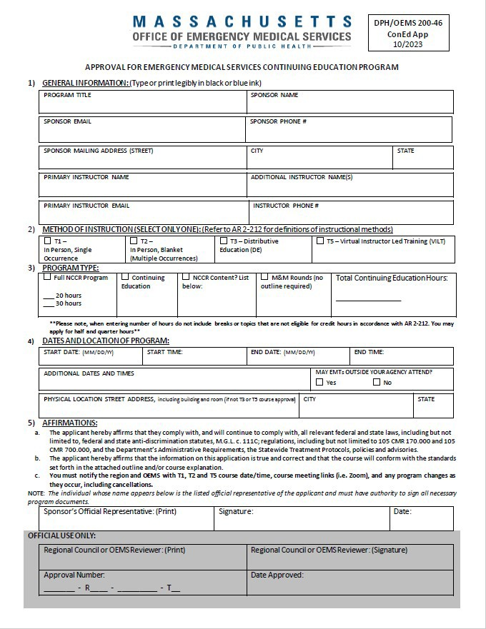
- Application is available at https://www.mass.gov/service- details/ems-continuing-education

- Section 1: General Information

- Section 2: Method of Instruction – Please only select one option

- Section 3: Program Type – Only enter number of hours that apply to topics related to EMS scope of practice, do not include breaks

- Section 4: Dates and Location of Program – Please check if outside EMTs can attend

- Section 5: Affirmations – Please print, sign and date

- Outline and Supporting Documentation

Applying for Continuing Education Approval: Application Example

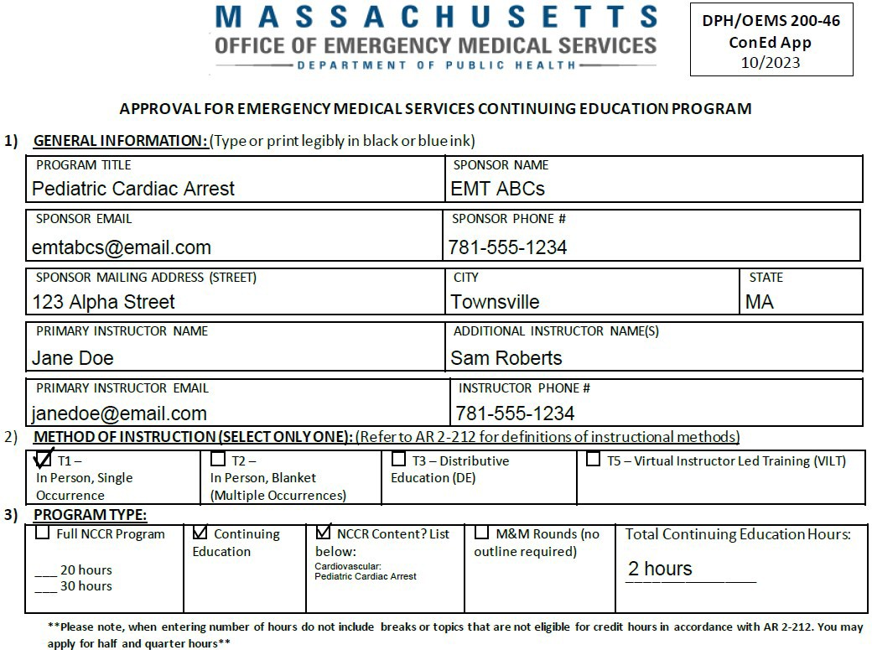

Applying for Continuing Education Approval: Application Example Continued

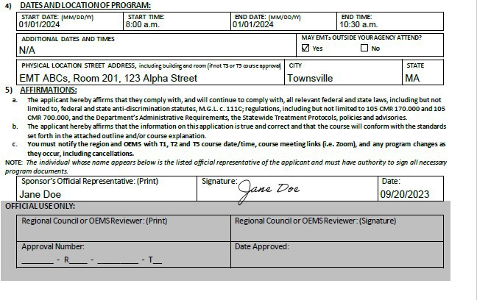

Applying for Continuing Education Approval: Continuing Education Outline

  - The last page of the application provides instructions for the course outline requirements
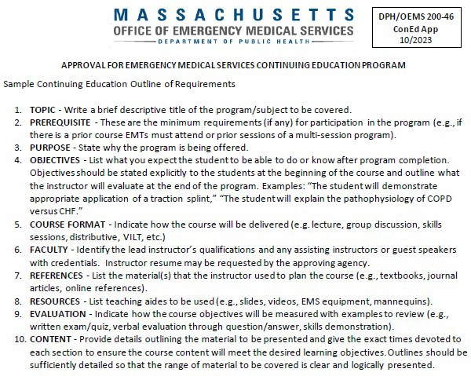

Applying for Continuing Education Approval: Outline – Course Content Requirements:

  - Provide details outlining the material to be presented

  - Allocate specific time intervals for each section to ensure the course content will meet the desired learning objectives

  - Outlines should be sufficiently detailed so that the range of material to be covered is clear and logically presented

  - Content must be:
    - Related to delivery of patient care within the EMS scope of practice, or
    - Within the defined roles and responsibilities of the EMT, or
    - Related to vaccine administration, in accordance with Special Protocols issued pursuant to a Commissioner’s Order under 105 CMR 700.003(H)

  - Include evaluation of course objectives

  - Refer to Administrative Requirement 2-212, EMS Continuing Education Standards for what topics are not eligible to receive approval for continuing education credit hours

Applying for Continuing Education Approval: Receiving an OEMS Approval Number

- Approval Number:
  - Cycle: 2324
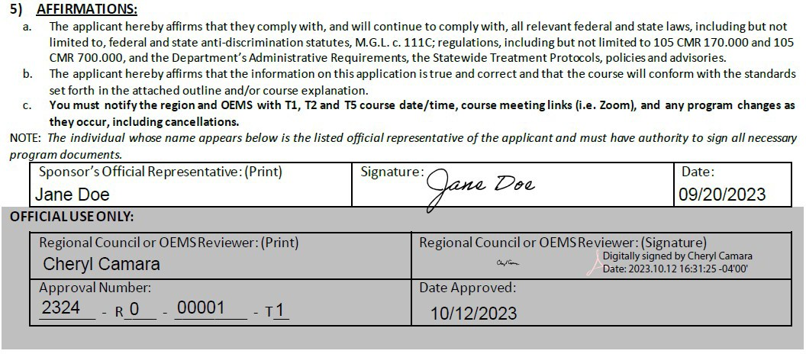
    - Course date between April 1, 2023 and March 31, 2024
    - Courses with multiple varying dates (T2 and T3) may only be taken for credit between April 1, 2023 and
March 31, 2024
  - Region: “R0”
    - “R0” is for the State OEMS office
    - “R[1-5]” corresponds to the Regional EMS Council issuing the approval
  - Number: 00001
    - Unique approval number assigned to your course
  - Method of Instruction: “T1”

Issuing Continuing Education Course Completion: Overview

  - Course sponsors must provide a completion certificate or copy of completed roster to all students at the end of the course
    - For T1, T2 or T4 courses, sponsors must ensure students and instructors sign an OEMS approved roster at each course meeting
    - For T3 or T5 courses, sponsors must ensure course attendance. This course attendance document must be retained by the course sponsor and is subject to audit

  - All continuing education records, including outlines and rosters must be retained by the sponsor for seven years. Students should use their MA EMT certification number (including prefix; E, A, or P) on the roster

  - Course credit may be awarded by hour, in segments of 15 minutes (1/4 hour). If a T1, T2, T4, or T5 class has met all if its objectives in less time than the awarded credit, the sponsor shall issue course completion documentation to reflect the actual course length

Issuing Continuing Education Course Completion: Course Completion Certificate Example

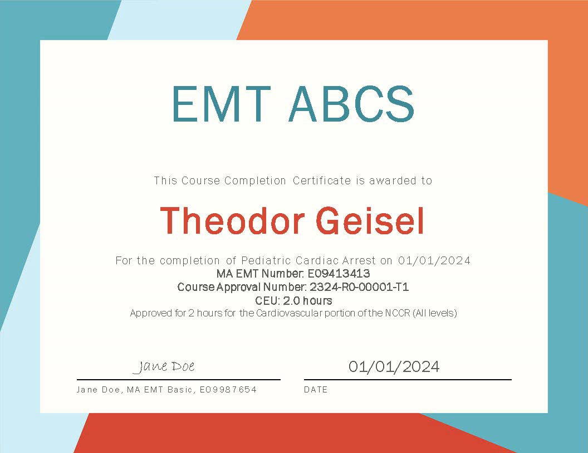

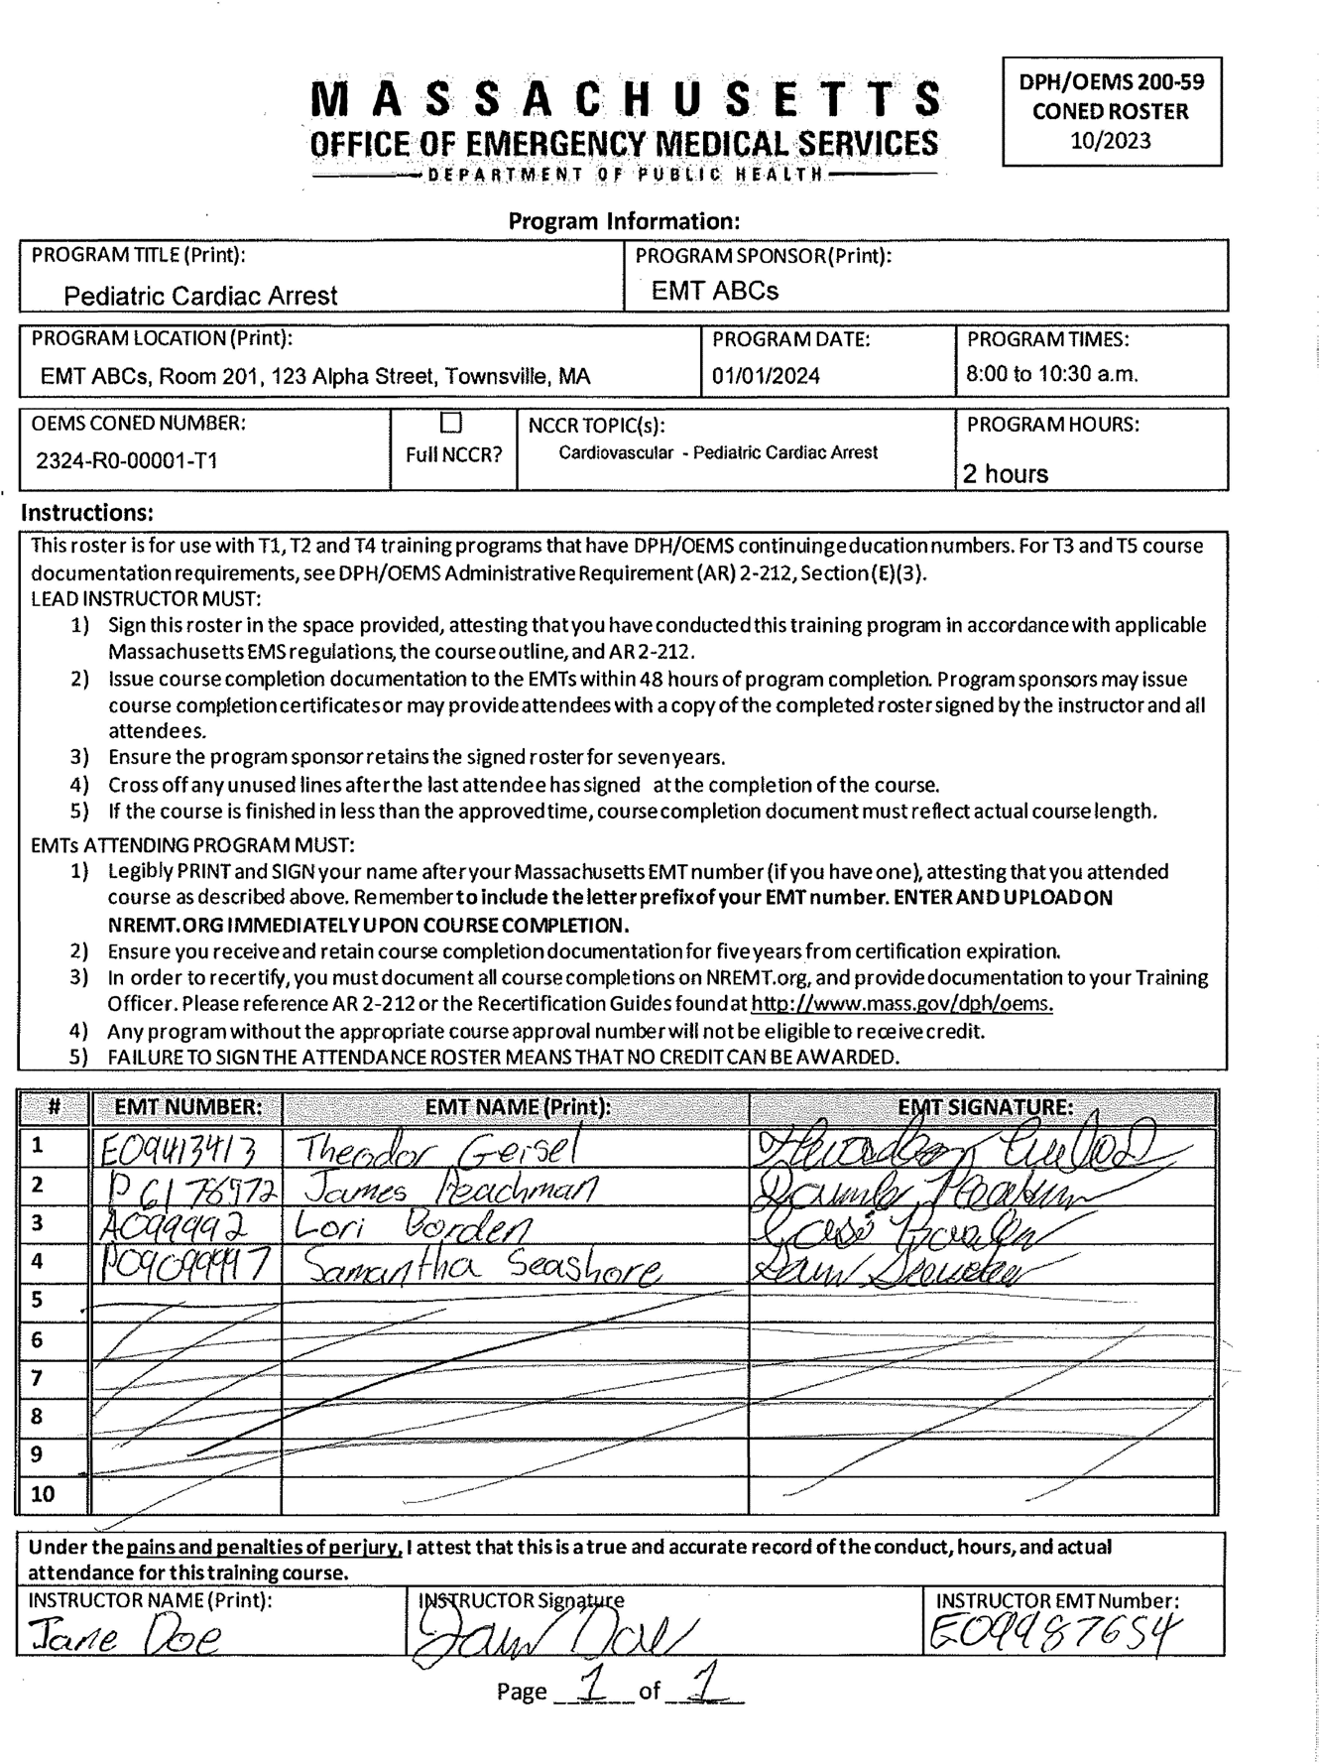
Issuing Continuing Education Course Completion: Course Roster Example

Massachusetts Department of Public Health | mass.gov/dph 35

Frequently Asked Questions (FAQ)

- “An EMT has paid the NREMT fee, but I cannot see nor approve their application in my ‘Verification’ tab.”
  - Payment for NREMT.org is separate from submission. If they have paid, please ensure they click the “Submit” button on their “Recert Application,” however, we strongly encourage you review and approve prior to submission. You can see all applications, regardless of submission status, by selecting “All Apps” on the verification page
- “I cannot see an EMT on my NREMT.org roster, but they are a part of my agency”
  - EMTs must request affiliation to appear on your NREMT.org agency roster. On the EMT’s NREMT dashboard, select
“Manage Affiliations” and have them select your agency. After they request affiliation, go into your “Affiliation Requests” tab to approve the affiliation
- “I see an updated expiration date on NREMT.org, but the Massachusetts site still shows their original expiration date. Will they update automatically?”
  - If NREMT.org indicates a renewed expiration date, Step A has been completed. Please ensure Step B (MA State Application and $125 fee) is completed on the MA eLicensing site, https://madph.mylicense.com/eGov. Only updated expiration dates on eLicensing indicate recertification is complete
- “My NREMT and MA expiration dates are different. How can I recertify?”
  - If the MA EMS certification is one year before the NREMT expiration date, contact OEMS for a One Year Alignment form to extend the MA EMS certification to match the NREMT expiration date. See https://www.mass.gov/doc/one-year- alignment-instructions-1/download for instructions
  - If the MA EMS certification is one year after the NREMT expiration date, renew the NREMT certification as normal and wait for the next year to align the MA EMS certification
  - If your NREMT certification has expired, you must regain NREMT in order to recertify your MA EMT certification

Frequently Asked Questions (FAQ)

- “How do I change my address and/or request a duplicate card?”
  - Address changes can be completed on the eLicensing website at https://madph.mylicense.com/eGov
  - If you need a duplicate card sent, please email a Duplicate Card request form available at https://www.mass.gov/how- to/change-information-on-your-ems-certification-card-or-request-a-duplicate-card
- “How long will it take for my card to arrive in the mail?”
  - Initial certification, recertification, and duplicate certification cards are batch printed once a week and we ask EMTs to wait 10 to 14 business days to receive their card in the mail
- “I submitted my recertification application, but it has not processed yet. What’s wrong?”
  - If NREMT.org indicates a renewed expiration date, Step A has been completed. Please ensure Step B (MA State Application and $125 fee) is completed on the MA eLicensing site, https://madph.mylicense.com/eGov. Only updated expiration dates on eLicensing mean recertification is complete
  - If both Steps A (NREMT.org) and Step B (eLicensing) are complete, but your MA EMS recertification has not processed yet, please contact OEMS at oems.recert@mass.gov
- “What happens if I have been arrested?”
  - If you have been convicted (which includes admission to sufficient facts that results in a continued without a finding or guilty plea) of a misdemeanor or felony, had your driver’s license suspended or revoked, been disciplined by another governmental licensing jurisdiction, or had your authorization to practice as an EMT suspended, you must report to your service and OEMS within five calender days. Please email oems.recert@mass.gov. Full details are at 105 CMR 170.937
- “When do I have to submit a CORI authorization?”
  - If you answer “yes” to Question 4 (for initial certification) or Question 2 (for recertification), you must submit the OEMS specific CORI form available at https://www.mass.gov/media/1086761 (notarized) and provide a written explanation and supporting documents (if you have them)

Frequently Asked Questions (FAQ)

- “Can I use my college/another healthcare provider course (non-EMS) for recertification?”
  - Any courses that have not been approved with an OEMS number can be submitted for special continuing education review (Special Credit) by completing the application found on our website at https://www.mass.gov/service- details/ems-continuing-education
  - In terms of non-approved EMS credit for recertification, it is the individual EMS personnel’s responsibility to take classes that have been pre-approved or understand that there is a chance any special credit submission may not be awarded
credit. Courses run with OEMS approval follow the AR 2-212 for Continuing Education Standards
- “Can I receive Continuing Education credit for completing AEMT/Paramedic school?”
  - If the entire course is completed within one Recertification Cycle, you can receive full NCCR, LCCR, and ICCR ConEd credit, meeting your EMT Basic or Advanced EMT Continuing Education requirements. If only part of the course was completed within your Recert Cycle, you may be eligible for LCCR and ICCR credit
  - Please contact your program director for the Continuing Education certificate and approval number
- “Can I receive Continuing Education credit for teaching a class?”
  - For continuing education, instructors may receive credit for courses holding OEMS approval, on a credit hour-for-credit hour basis, for one occurrence per recertification cycle
  - For initial course instructors, full recertification credit is available if you have taught a complete course at your level of certification. Obtain a letter attesting to dates/hours and course registration number, from the Program Director, and submit to oems.coned@mass.gov

Frequently Asked Questions (FAQ)

- “I’ve been told I’m being audited, what does this mean?”
  - Both OEMS and NREMT may audit submitted recertification up to 5 years after submission. Read and follow the instructions in the email. Retrieve and submit course records as requested. In the event courses submitted were not valid, you’ll be provided specific instructions on how to resolve
- “Military deployments or medical hardships have impacted my ability to recertify, what are my options?”
  - In some circumstances, OEMS is able to provide extensions to complete continuing education. Please contact OEMS for specific guidance at oems.recert@mass.gov
- “I need a receipt for my payment (initial or recertification)”
  - Receipts are generated only at the time of payment. Don’t forget to enter your email address/phone number on the
payment submission page, in order to receive a receipt. OEMS cannot issue official receipts, but we can issue unofficial payment confirmations

- Laws and regulations for OEMS
  - https://www.mass.gov/lists/laws-and- regulations-for-oems
  - EMS Systems Regulations, 105 CMR 170.000
  - Administrative Requirement 2-212, EMT Continuing Education Standards

- National EMS Education Standards
  - https://nremt.org/Document/resources

- eLicensing (State certification site; Step B)
  - https://madph.mylicense.com/eGov/Login.aspx

- National Registry (NREMT; Step A)
  - https://nremt.org/
- Online Verification Site
  - https://madph.mylicense.com/verification
  - This would allow you to show your current EMT status on a smartphone, in lieu of carrying your physical card when staffing an ambulance.

- Regional EMS Offices
  - https://www.mass.gov/service-details/ems-regions-in- massachusetts

- MA OEMS Recertification Guides
  - https://www.mass.gov/how-to/renew-your-emt-advanced- emt-or-paramedic-certification

References, Regulations, Educational Standards, etc.
- OEMS Information
  - https://www.mass.gov/orgs/office-of- emergency-medical-services

- Initial, Recertification, and General Questions:
Contact Information
  - Oems.recert@mass.gov
  - 617-753-7309

- Continuing Education:
  - Oems.coned@mass.gov

- eLicensing HelpDesk (I.T. login and payment issues):
  - elicensing.helpdesk@state.ma.us
  - 617-973-0935

- National Registry (NREMT):
  - support@nremt.org
  - 614-888-4484

- OEMS Ambulance Regulation Program:
  - Oems.ambulance@mass.gov
  - 617-753-8051
- Initial Training Programs:
  - Lynne.doyle@mass.gov

- Regional EMS Council Offices:
  - Region I:
    - https://wmems.org/contact
  - Region II:
    - https://www.cmemsc.org/index.php/our-team-2
  - Region III:
    - https://www.neems.org/contact-us/
  - Region IV:
    - https://www.mbemsc.org/contact
  - Region V:
    - https://www.semaems.com/contact/
- All OEMS Contacts:
  - https://www.mass.gov/service-details/contact-the-oems- team

