**Disaster Recovery Action Plan**

**FY 2013**

**Massachusetts**

**Community Development Block Grant Program**



**Commonwealth of Massachusetts**

**Charles D. Baker, Governor**

**Department of Housing and Community Development**

**Chrystal Kornegay, Undersecretary**

**September 3, 2013**

**Revised: October 9, 2013**

**Revised March 25, 2014**

**Revised June 20, 2014**

**Revised December 26, 2014**

**Revised August 21, 2015**

**INTRODUCTION**

The Commonwealth of Massachusetts is required to publish an Action Plan for Disaster Recovery (Action Plan) that describes the proposed use of U.S. Department of Housing and Urban Development (HUD) Community Development Block Grant Disaster Recovery (CDBG-DR) funding associated with the Disaster Relief Appropriations Act of 2013 (Public Law 113-2) for disaster relief of unmet needs resulting from five (5) storm events that occurred during 2011 and 2012. These five events – two severe winter storms, a tornado, Tropical Storm/Hurricane Irene and Hurricane Sandy – resulted in the following federal disaster declarations applicable to all 14 Massachusetts counties.

* FEMA Disaster 1959: Severe Winter Storm 1/11/11 – 1/12/11 (Berkshire, Essex, Hampden, Hampshire, Middlesex, Norfolk & Suffolk Counties)
* FEMA Disaster 1994: Tornado 6/1/11 (Hampden & Worcester Counties)
* FEMA Disaster 4028: Tropical Storm Irene 8/27/11 – 8/29/11 (Barnstable, Berkshire, Bristol, Dukes, Franklin, Hampden, Hampshire, Norfolk & Plymouth Counties)
* FEMA Disaster 4051: Severe Winter Storm 10/29/11 – 10/30/11 (Berkshire, Franklin, Hampshire, Hampden, Middlesex & Worcester Counties)
* FEMA Disaster 4097: Hurricane Sandy 10/27/12 – 11/8/12 (Barnstable, Bristol, Dukes, Nantucket, Plymouth & Suffolk Counties)

This Action Plan is required, pursuant to the U.S. Department of Housing and Urban Development’s Notice of Funding Availability, provided in Federal Register / Volume 78, Number 103, Docket No. FR-5696-N-03. This document will describe:

* The effects of the disasters, and the State and Federal responses to date;
* The Commonwealth’s assessment of need and strategy for Disaster Recovery;
* Eligible affected areas and applicants;
* The methodology to be used to distribute funds to those areas and applicants;
* Activities for which funding may be used;
* The Commonwealth’s public outreach and citizen participation process used to develop the Action Plan.

This Action Plan, and subsequent amendments, will be used by the Department of Housing and Community Development (DHCD) to guide the distribution of $7,210,000 (a minimum of $1,388,800 must be spent in Hampden County) of CDBG-DR funds toward meeting unmet housing, infrastructure, business and job retention/creation, public service, public facility, disaster recovery planning and other needs in counties designated as Presidential Disaster Areas. Amendments to this Plan will be made as additional funds are obligated and for the reasons identified in the section titled Action Plan Amendments.

The Act provides that funding under the CDBG-DR Program must be used “for necessary expenses related to disaster relief, long-term recovery, restoration of infrastructure and housing, and economic revitalization in the most impacted and distressed areas resulting from a major disaster.”

The Federal Register Notice also imposes strict expenditure and compliance deadlines on the Commonwealth. Accordingly, HUD is allowing Grantees to request less than the full funding amount in a Partial Action Plan. The Commonwealth of Massachusetts, like other states to which CDBG-DR Program funds were allocated by HUD, will pursue incremental obligation of the funding to support its relief and restoration programs and activities to ensure compliance with HUD’s deadlines. Specifically, the Commonwealth is requesting that HUD make $3,638,739 million available immediately upon approval of this Action Plan.

With respect to CDBG-DR Program eligible activities, the State must also ensure that at least 50% of its CDBG-DR grant funds are used for activities that benefit low- and moderate–income (“LMI”) persons. LMI persons are defined for the purposes of the CDBG-DR Program as persons and families whose income does not exceed 80% of the area median income (“AMI”), as determined by HUD. This 50% requirement applies to the Commonwealth’s expenditure of the entirety of the funding, less administration and planning, and does not apply to each individual program or activity. For the purposes of the total CDBG-DR allocation, this would mean a minimum of $3,424,750 of these funds must be obligated to the national objective of benefitting low- and moderate- income persons.

As set forth in the Federal Register Notice, the funding cannot be used for any of the following: to assist second homes (as defined in IRS Publication 936); and to assist private utilities or organizations.

In addition, all expenditures of the funding, other than Administration and Planning, must meet at least one of the three federally-mandated national objectives: low- and moderate–income benefit; elimination of slums or blight; and urgent need.

Any activity not listed in the Housing and Community Development Act, as modified by the Federal Register Notice, is not an activity for which any of the funding can be used unless a specific waiver of such ineligibility has been granted by HUD and/or the federal Office of Management and Budget. HUD has granted a number of general program waivers which have provided greater flexibility to the administration of the program.

*Action Plan Contact*

Mark Southard, Community Development Manager

Department of Housing and Community Development

100 Cambridge Street, Suite 300

Boston, MA 02114

Phone: (617) 573-1436

Email: [Mark.Southard@state.ma.us](mailto:Mark.Siegenthaler@state.ma.us)

**DISASTER-RELATED IMPACTS**

As detailed in the narratives contained Appendix 2, five (5) disaster events occurred in the Commonwealth between January 2011 and December 2012 that are the declared disaster storms for the CDBG-DR funding available to the Commonwealth. The events affected all 14 counties and 351 municipalities at some time during the two-year period. Consequently, the entire population of Massachusetts was affected by one or more of the events.

A statistical view of the Commonwealth, at that time, is contained in Table 1. The tables also break out statistics for Hampden County, identified by HUD as a “most impacted and distressed county”.

**Table 1.**

|  |  |  |
| --- | --- | --- |
| **Demographics** | **MA** | **Hampden County** |
| Population, 2012 estimate | 6,646,144 | 465,923 |
| White persons percent, 2012 | 83.70% | 84.00% |
| Black or African American persons, 2012 | 7.90% | 10.50% |
| American Indian and Alaska Native persons, 2012 | 0.50% | 0.80% |
| Asian persons, 2012 | 5.80% | 2.20% |
| Native Hawaiian and Other Pacific Islander persons, 2012 | 0.10% | 0.20% |
| Two or More Races, 2012 | 2.00% | 2.40% |
| Hispanic or Latino, 2012 | 10.10% | 22.00% |
| White, not Hispanic or Latino, 2012 | 75.80% | 66.60% |
| High school graduate or higher, percent of persons age 25+, 2007-2011 | 88.90% | 83.50% |
| Bachelor's degree or higher, percent of persons age 25+, 2007-2011 | 38.70% | 23.90% |
|  |  |  |
| Housing units, 2011 | 2,818,940 | 192,197 |
| Homeownership rate, 2007-2011 | 63.60% | 63.00% |
| Housing units in multi-unit structures, percent, 2007-2011 | 41.80% | 38.80% |
| Median value of owner-occupied housing units, 2007-2011 | $343,500 | $202,500 |
| Building permits, 2012 | 11,111 | 330 |
| Households, 2007-2011 | 2,522,409 | 177,954 |
|  |  |  |
| Per capita income in the past 12 months, 2007-2011 | $35,051 | $25,363 |
| Median household income, 2007-2011 | $65,981 | $48,866 |
| Persons below poverty level, percent, 2007-2011 | 10.70% | 16.60% |

**SOURCE:** American Community Survey (ACS) 2006 – 2011 Five-Year estimates

**DISASTER ASSISTANCE**

The CDBG Disaster Recovery Program is designed to supplement other forms of assistance.

Private insurance, Federal Emergency Management Agency (FEMA) programs, and Small Business Administration (SBA) loans are the primary sources of disaster assistance available to property owners in the counties designated as Presidential Disaster Areas.

**UNMET NEEDS**

The impacts of the June 1, 2011 Tornado, Tropical Storm Irene and Hurricane Sandy exceed the available primary disaster assistance. To address the remaining unmet needs, the U.S. Department of Housing and Urban Development allocated CDBG-DR funds to Massachusetts for use in 2013. To date, the unmet needs described below have been identified by State agencies, municipalities, and public housing authorities. However, as recovery from these disasters proceeds, and insurance benefits/SBA loans are realized, additional unmet needs may be identified. Additional unmet needs will be documented in Action Plan amendments.

The Commonwealth’s needs assessment involved the following:

1. Outreach to units of general local government and non-profit organizations, regional planning agencies, community development corporations, other interested parties, and consultation with the Department of Housing and Community Development (DHCD) Public Housing Division on behalf of eligible public housing authorities and shelters.

2. Review of Letters of Interest solicited directly from municipal officials and other interested parties.

3. Review of documents available from FEMA, the Massachusetts Emergency Management Agency (MEMA), the SBA, the Towns of Monson and West Springfield, local media and other sources regarding impacts and disaster assistance.

4. Coordination with other state and federal funding agencies involved in response and recovery efforts.

Outreach efforts by the Department of Housing and Community Development (DHCD) are described in the Citizen Participation section of this Action Plan. The request for Letters of Interest is attached as Appendix 5.

Unmet Public Assistance Needs

|  |  |  |  |  |  |  |
| --- | --- | --- | --- | --- | --- | --- |
| **Table 2.** |  |  |  |  |  |  |
| **FEMA Public Assistance Preliminary Damage Estimates (all categories)** | | | | | |  |
| **Category** | **#1959** | **#1994** | **#4028** | **#4051** | **#4097** | **TOTALS** |
| A | $312,000 | $8,794,285 | $2,836,400 | $55,695,688 | $2,097,465 | $69,735,838 |
| B | $19,545,550 | $5,311,318 | $1,180,100 | $9,330,936 | $2,252,329 | $37,620,233 |
| C | $0 | $113,105 | $9,969,677 | $81,500 | $190,463 | $10,354,745 |
| D | $0 | $48,051 | $9,026,500 | $283,200 | $433,171 | $9,790,922 |
| E | $10,000 | $10,022,270 | $0 | $345,608 | $6,216,781 | $16,594,659 |
| F | $0 | $261,124 | $2,037,400 | $463,657 | $859,989 | $3,622,170 |
| G | $0 | $58,618 | $35,000 | $12,389,920 | $10,159,100 | $22,642,638 |
| **TOTALS** | **$19,867,550** | **$24,608,771** | **$25,085,077** | **$78,590,509** | **$22,209,298** | **$170,361,205** |
| **Table 3.** |  |  |  |  |  |  |
| **FEMA Public Assistance Preliminary Damage Estimates (permanent work only)** | | | | | |  |
| **Category** | **#1959** | **#1994** | **#4028** | **#4051** | **#4097** | **TOTALS** |
| C | $0 | $113,105 | $9,969,677 | $81,500 | $190,463 | $10,354,745 |
| D | $0 | $48,051 | $9,026,500 | $283,200 | $433,171 | $9,790,922 |
| E | $10,000 | $10,022,270 | $0 | $345,608 | $6,216,781 | $16,594,659 |
| F | $0 | $261,124 | $2,037,400 | $463,657 | $859,989 | $3,622,170 |
| G | $0 | $58,618 | $35,000 | $12,389,920 | $10,159,100 | $22,642,638 |
| **TOTALS** | **$10,000** | **$10,503,168** | **$21,068,577** | **$13,563,885** | **$17,859,504** | **$63,005,134** |
| **FEMA Public Assistance Grants ( as of 8/20/13)** | $0 | $4,156,516 | $18,365,837 | $4,163,566 | $2,383,062 | $29,068,981 |
| **UNMET NEED** | **$10,000** | **$6,346,652** | **$2,702,740** | **$9,400,319** | **$15,476,442** | **$33,93,153** |
|  |  |  |  |  |  |  |
| 1959: Severe Storm, January 2011 | | | Category A: Debris Removal | |  |  |
| 1994: Tornado |  |  | Category B: Emergency Protective Measures | | |  |
| 4028: Tropical Storm Irene | |  | Category C: Roads & Bridges | |  |  |
| 4051: Severe Storm, October 2011 | | | Category D: Water Control Facilities | | |  |
| 4097: Hurricane Sandy | |  | Category E: Buildings & Equipment | | |  |
|  |  |  | Category G: Other (parks, rec. facilities, etc.) | | |  |

Impact and need data by County for each disaster is contained in Appendix 4.Unmet Housing Needs

**Table 4. Housing Impact**

|  |  |  |  |  |  |
| --- | --- | --- | --- | --- | --- |
| **Disaster Declaration** | **# Destroyed** | **# Major Damage** | **# Minor Damage** | **# Affected** | **Total Impacted Housing Units** |
| Tornado (#1994) | 319 | 600 | 300 | 250 | 1,469 |
| Tropical Storm Irene (#4028) | 84 | 246 | 43 | 67 | 440 |
|  | 403 | 846 | 343 | 317 | 1,909 |

**SOURCES:** FEMA, SBA

**Table 5. Housing Unmet Need**

|  |  |
| --- | --- |
| **Preliminary Damage Assessment (PDA) – Housing** | |
| Estimated Housing Damage: Disaster 1994 | $32,057,019 |
| Estimated Housing Damage: Disaster 4028 | $ 9,601,830 |
| Total Estimated Housing Damage | $41,658,849 |
| **Housing Assistance** | |
| FEMA IA: #1994 | $ 3,015,224 |
| FEMA IA: #4028 | $ 5,303,982 |
| SBA Homeowner Assistance: #1994 | $11,369,100 |
| SBA Homeowner Assistance: #4028 | $ 1,733,300 |
| State Tornado-related Housing Rehabilitation Assistance | $ 564,000 |
| Total Assistance Provided | $21,985,606 |
| **PDA Less Federal Assistance** | **$19,673,243** |

**SOURCES:** FEMA, SBA

In May 2012, the Commonwealth awarded $564,000, appropriated by the Massachusetts legislature, to the Pioneer Valley Planning Commission (PVPC) for the purpose of providing housing rehabilitation assistance to households in ten (10) Hampden and Worcester County communities severely affected by the tornadoes. Among the provisions of the program design were requirements that at least 60% of the funds benefit households with incomes that do not exceed 80% of AMI, and at least 85% of the funds benefit households with incomes that do not exceed 100% AMI.

More detailed information regarding the program is contained in Appendix 2.

Unmet Economic Assistance Needs

|  |  |  |  |
| --- | --- | --- | --- |
| **Table 6.** |  |  |  |
| **Storm** | **Business Assistance Requested** | **SBA Business Loans Provided** | **Unmet Need** |
| Tornado (#1994) | $8,828,000 | $2,398,300 | $6,429,700 |
| Tropical Storm Irene (#4028) | $1,025,000 | $854,700 | $170,300 |
| TOTALS | $9,853,000 | $3,253,000 | **$6,600,000** |
|  |  |  |  |

In many ways, the economic effects and full impacts of the designated disasters may never be known. As indicated above, SBA loans were provided in response to only two of the five disasters. No identifiable industry type was particularly affected by the disasters.

Business recovery funds and services from three regional agencies working to help businesses and their communities were made available in response to the same two disasters. The recovery funds are part of a $600,000 grant from the federal Economic Development Administration to Common Capital, the Scibelli Enterprise Center (SEC), and the Pioneer Valley Planning Commission. The funds and services are available to businesses in Hampden, Hampshire, Franklin, and Berkshire counties severely affected by flooding and damage from the tropical storm and in tornado-damaged areas of Springfield, West Springfield, Westfield, Brimfield, and Monson.

Common Capital provides $500,000 towards the creation of a business recovery loan fund for repair and renovation of buildings and facades, landscaping, and infrastructure of businesses that were damaged by the storms. Funds also may be used to provide working capital for business recovery and business growth of existing businesses as well as new start-up businesses in the disaster recovery communities.

In addition to capital, businesses will also have access to mentoring services and space at the Scibelli Enterprise Center. Businesses can benefit from the advice and expertise of seasoned regional professionals and entrepreneurs committed to helping business owners succeed. Facilities, including the use of conference rooms, at the SEC may also be made available to the businesses as needed. The Pioneer Valley Planning Commission will also integrate business needs into regional disaster preparedness and recovery planning.

**METHOD OF DISTRIBUTION**

HUD allocated CDBG Disaster Recovery funds based on the best available Disaster Declaration impact and unmet needs data. HUD’s allocation methodology is described in Appendix A of the Federal Register, Volume 78, Number 103, Docket No. FR-5696-N-03. Overall, a total of $29,106,000 has been allocated to assist Massachusetts. Hampden County is designated a “most impacted and distressed county”. A minimum of 80% of the grant funds must be expended in Hampden County and this is accomplished through the direct allocation of $21,896,000 to the City of Springfield and the required use of $1,388,800 in state-allocated funds.

The Commonwealth has been allocated $7,210,000 in CDBG-DR funds. As noted above, $1,388,800 of this amount must be obligated to projects in Hampden County and the balance – $5,821,200 – is available for projects in the rest of the state. Consistent with program requirements, $360,500 (5%) will be set aside for administrative purposes ($69,440 for activities in Hampden County and $291,060 for activities in the rest of the state).

Total funds available for activity costs (less administration) are $1,319,360 for activities in Hampden County and $5,530,140 in the rest of the state. Of this combined amount available for activities - $6,849,500, at least fifty percent (50%) or $3,424,750, must benefit low or moderate income persons. The remaining funds will be awarded to proposals that meet any of the three National Objectives.

Table 7 details the available amounts and requirements covered by this Action Plan.

**Table 7.**

|  |  |  |  |  |
| --- | --- | --- | --- | --- |
| Total Commonwealth Allocation | Amount designated for Hampden County | Amount available for the balance of MA counties | Amount available for administration | Minimum amount required to benefit LMI persons |
| $7,210,000 | $1,388,800 | $5,821,200 | $360,500 | $3,424,750 |

Eligible Counties and Applicants

All units of general local government in Massachusetts are eligible to apply for CDBG-DR funds based on the named Presidential Disaster declarations.

As provided in Docket No. FR-5696-N-03, requirements of 42 U.S.C. 5306 are waived to the extent necessary to allow a state to use its disaster recovery grant allocation directly to carry out state-administered activities. DHCD reserves the right to distribute CDBG-DR funds to a state agency or to a direct sub-recipient of the state but does not anticipate doing so. Non-profit organizations serving LMI persons are also eligible direct sub-recipients.

Every activity must meet one of the CDBG national objectives: Benefiting Low and Moderate Income Persons; Preventing or Eliminating Slums or Blight; and Meeting Urgent Needs.

Limitation on Eligible Locations

Within Massachusetts, generally only projects and activities located outside of Coastal Barrier Resource System (CBRS) Units will be eligible for CDBG-DR funds, pursuant to HUD guidance provided March 19, 2013. Locations of CBRS Units are available on the U.S. Fish and Wildlife Service website, at <http://www.fws.gov/CBRA/Maps/Mapper.html>. Furthermore, no activity in an area delineated as a special flood hazard area or equivalent in FEMA’s most recent and current data source will be eligible, unless the activity is designed or modified to minimize harm to or within the floodplain. At a minimum, actions to minimize harm must include elevating or flood-proofing new construction and substantial improvements to one foot above the base flood elevation and otherwise acting in accordance with U.S. Executive Order 11988 and 24 CFR part 55.

Eligible Activities

The overall list of eligible CDBG activities is set forth by 42 U.S.C. 5305 and amended by FR- 5696-N-03.

Examples of eligible activities include:

* Constructing or rehabilitating public facilities such as streets, and water, sewer and drainage systems, government buildings, and neighborhood centers;
* Rehabilitation of homes and buildings damaged by the disaster;
* Purchase of damaged properties in a flood plain and relocating residents to safer areas;
* Homeownership activities such as down payment assistance, interest rate subsidies and loan guarantees for disaster victims;
* Economic development activities;
* Public services (generally limited to no more than 15 percent of the grant); and,
* General administration costs (limited to no more than five (5) percent of the grant)

HUD’s Environmental Review Procedures and Floodplain Management regulations, codified at 24 CFR 58 and 24 CFR 55, respectively, apply.

Housing Activities

CDBG-DR funds may be used for assisting LMI households with rehabilitation, reconstruction, mitigation, clearance and demolition activities to address unmet housing needs as a result of the declared disasters. Second homes, as defined in IRS Publication 936 (mortgage interest deductions), are not eligible for CDBG-DR funds.

Eligible Housing Activities include, but are not limited to:

1. Rehabilitation/reconstruction of existing LMI housing

2. Clearance and removal of debris on LMI properties, and adjacent properties

3. Demolition of structures on LMI properties

Public Facilities and Infrastructure Activities

CDBG funds may be used for projects that will repair, rehabilitate, or modify public infrastructure and facilities affected by the disaster. Examples include repair, rehabilitation, and replacement of water and sewer systems, streets, storm drainage, and public buildings (eligible public buildings include structures for both citizen use and local government administration), and payment of non-federal share for emergency repairs.

Economic Recovery

CDGB-DR funds may be used for rehabilitation of small businesses, as defined by IRS Publication 936, which suffered physical damage to property or equipment due to the disaster. All economic recovery activities shall predominately benefit LMI persons, under the LMI Jobs National Objective.

Eligible Economic Recovery Activities include:

1. Rehabilitation/reconstruction of existing businesses damaged during the declared disasters.

2. Replacement of fixed equipment damaged during the declared disasters.

3. Clearance and removal of debris resulting from the declared disasters.

4. Business relocation costs, pursuant to the Uniform Relocation Act.

Mitigation activities are only allowed if they are necessary to the further operation of the business due to ongoing severe storm or flood danger, and can be qualified under the LMI Jobs National Objective. Funds will be distributed to units of general local government, which will then distribute funds to business owners.

Planning Activities

CDBG-DR funds may be used for the development of disaster recovery or hazard mitigation policies, plans, and capacity building. Disaster recovery planning includes mapping, specific comprehensive plan updates, zoning/building code ordinance revisions, floodplain/coastal hazard plans, recovery ordinances, coastal hazard studies directly related to impacts of the disaster, infrastructure and engineering studies necessary for disaster recovery and mitigation, and updating building requirements. All planning activities must relate to the one of the events covered by the Presidential Declarations.

Administration

Grant administration, including grant administration by sub-recipients will include direct personnel expenses (salary and fringe benefits), direct and indirect expenses, equipment, consultants, and other operating expenses involved in selection, funding, assisting, and monitoring sub-grantee projects, detailed quarterly reporting to DHCD and HUD, and documentation of adherence to all laws and regulations.

Project Selection

On August 2, 2013, DHCD requested letters of interest from units of general local government in Massachusetts counties affected by the events covered in the Presidential Declarations (see Appendix 3). Respondents were asked to submit a narrative describing each project and address specific questions used to determine eligibility. Twenty-seven (27) municipalities responded with requests for 32 projects with cost estimates exceeding the State’s total CDBG-DR allocation.

DHCD is responsible for verifying that each proposed project addresses the impacts of at least one declared disaster, fulfills at least one CDBG national objective and meets threshold and eligibility requirements as articulated in the request for Letters of Interest and federal regulations.

The Letters of Interest received by DHCD ultimately reflect the actual remaining need in communities affected by the designated disasters. A significant period of time has elapsed since many of the storm events damaged the Commonwealth and this has affected the identification and submission of projects. Just as initial estimates indicated the greatest expected need for infrastructure repairs, the Letters of Interest requested significantly greater amounts of funding to address unmet infrastructure needs than any other activity. No proposals were received, for example, for economic development or economic recovery activities. SBA data provided demonstrates emergency response activity in this subject area based on assistance as a result of two of the five declared disasters.

Information about the Letters of Interest received is included in Appendix 6.

In order to address this expression of need indicated by respondent communities, the factors and priorities the Department considered in evaluating proposals include, but are not limited to, the following:

Threshold Criteria

* Eligibility, National Objective and other regulatory requirements
* Feasibility
* Timeliness of project implementation
* Unmet need

High Priorities

* Projects benefitting low and moderate income persons and fulfillment of low and moderate income National Objective funding level requirements
* Projects addressing unmet needs in communities that have 51% or more low and moderate income residents
* Infrastructure and public facilities activities that primarily address unmet, disaster-related conditions and that further community recovery

Moderate Priorities

* Housing rehabilitation activities that primarily address unmet, disaster-related conditions
* Infrastructure and public facilities activities that address general rehabilitation needs in addition to unmet, disaster-related conditions
* Economic Development activities that primarily address unmet, disaster-related conditions

Low Priorities

* Housing rehabilitation activities that address general rehabilitation needs in addition to unmet, disaster-related conditions
* Projects located in jurisdictions already receiving CDBG-DR funds
* Multiple activities in the same community (except in Hampden County)
* Projects addressing conditions exacerbated by the named Declarations
* Reimbursement for past expenditures
* Geographic distribution

Eligible projects identified in the initial letters of interest have been divided into three categories. Category 1 projects are recommended for approval as part of the Action Plan. The projects are listed in Table 8; Appendix 5 contains summary descriptions of these projects. Before a contract can be executed by DHCD, complete application materials must be submitted online and reviewed for each Category 1 project. Due to private acquisition of the subject property proposed in West Springfield’s Letter of Intent, alternatives site(s) have been identified for recovery activities in the same geographic area of the community. A revised project description is contained in Appendix 7 and in Table 8. Upon approval of this Plan and the proposed projects, DHCD will provide further application guidance and assistance to communities.

In the December 26, 2014, Action Plan Amendment, two Category 1 project award amounts were amended to increase funding for the projects.

1. The Town of Fairhaven requested and was awarded an additional $168,870 in funding due to a shortfall of funds. The Town also allocated $25,000 in local funding. This enabled a contract to be awarded to the lowest eligible bidder as the bids received were in excess of the original amount requested.
2. The Town of Northbridge requested and was awarded an additional $259,900 to cover projected increased costs associated with designing and rehabilitating the Rockdale Youth Center. However, these additional funds are still below the lowest responsible bid that was submitted when the project was bid in July, 2015. Additional funds in the amount of $758,701 are requested through this August 21, 2015 amendment to enable the Town to award the contract to the lowest responsible bidder.

This August 21, 2015 Action Plan Amendment requests funding for two additional Category 1 projects due to project shortfalls.

1. The Town of Buckland requests an additional $250,000 to complete the Clesson Brook Road Bridge rehabilitation. Increased costs are projected by the engineer and as a result of input from the Massachusetts Department of Transportation.
2. The Town of West Springfield requests an additional $100,810 in unforeseen costs associated with the cleanup and demolition at the Standard Plating project.

Revised totals are shown on Table 8.

This August 21, 2015 Action Plan Amendment requests funding for two Category 3 projects due to project shortfalls.

1. The Town of Holland requests an additional $68,875 to complete the Over the Top Road Drainage project. The initial estimate to complete this project was insufficient.
2. The Town of Norton requests an additional $100,327 to complete the Woodland Meadow Housing Authority project to address design and contingency budget shortfalls.

Finally, this August 21, 2015 Action Plan also requests to deallocate $120,000 of funds that were awarded for a Category 1 project to the Town of Monson due to performance issues.

Category 2 projects are those letters that proposed Housing Rehabilitation activities. DHCD has funded significant levels of housing rehabilitation through its annual CDBG program in many communities. Several letters of interest have been received from communities that are recipients of CDBG housing rehabilitation funds. As indicated above, for CDBG-DR, DHCD intends to prioritize funding to housing rehabilitation activities that primarily address unmet, disaster-related conditions. The Category 2 respondents will be requested to provide additional information to ensure that the proposed rehabilitation activities are consistent with DHCD’s priorities for CDBG-DR funded rehabilitation activities.

DHCD contacted all six communities that submitted letters of interest for Housing Rehabilitation activities in May 2014 to determine if they were able to move forward with the proposed housing activities and could operate the programs within the CDBG-DR parameters for housing assistance. Monson (lead community for regional housing rehabilitation program for Monson, Brimfield and Wilbraham) was the only community indicating that they could operate a housing rehabilitation program within the CDBG-DR guidelines. However, DHCD needs additional information. Funding in the amount of $570,675 is requested for the Town of Norton for a drainage and sewer project at the Woodland Meadow Housing Authority. A project description is contained in Appendix 7 and Table 8.

Several additional submissions (Category 3) expressed interest and identified potentially eligible activities of high or moderate priority but lacked sufficient detail to be recommended at this time. Additional information will be requested. Additional information has been received regarding the Colrain Town Highway Garage sufficient to allow DHCD to recommend approval of funding. (June 2014) A project description is contained in Appendix 7 and Table 8. Additional information has been received from the Town of Holland regarding the Over the Top Road drainage and erosion control project sufficient to allow DHCD to recommend approval of funding in the amount of $88,200. A project description is contained in Appendix 7 and Table 8. All Category 2 and 3 respondents are listed in Tables 9 and 10.

Through the December, 2014 Amendment funds were also requested for a microenterprise activity and housing rehabilitation in the Town of Brimfield. $236,250 was awarded to the Town of Brimfield to fund an economic development and housing rehabilitation project.  The funds will assist a tree farm and carriage/sled ride operation located on Hollow Road, Brimfield, which has been unable to fully operate since sustaining extensive damage from FEMA disaster 1994 (June, 2011 tornado). A project description is contained in Appendix 7 and Table 8.

The remaining letters of interest will remain in consideration during the time in which detailed applications are submitted and final determinations of eligible, feasibility and funding amounts are made. However, DHCD reserves the right to solicit additional letters of interest and proposals for projects consistent with the Department’s CDBG-DR priorities and program requirements.

All projects must submit complete applications and provide duplication of benefits documentation for review by DHCD prior to any award of funds. In addition to detailed descriptions of the proposed activities to be conducted, applicants must submit information normally required by and identified in applications to the state’s CDBG Small Cities program including program design details, a management plan and other organizational materials to ensure that the grantee has the capacity, or has budgeted to provide the capacity, to effectively carry out the proposed activities.

In some case, the Letters of Interest received by DHCD included projects that did not meet eligibility requirements. Ineligible projects were not evaluated further. If a respondent submitted both eligible and ineligible projects, only the eligible projects were evaluated.

If, at any time, DHCD determines that a project does not meet a national objective, or is otherwise ineligible for CDBG-DR funds, DHCD reserves the right to de-obligate and/or recapture funds. In reviewing a letter of interest and/or application and awarding a grant, the Commonwealth may eliminate or modify a proposed activity or modify proposed funding where it is determined that such changes are necessary to comply with program requirements, national objectives, and threshold requirements.

This Action Plan allocates $3,638,739 to eligible activities. A minimum of 50% of the State’s total allocation must be expended on activities primarily benefiting low and moderate income persons. Forty-four percent (44%) of the funds for the currently proposed projects are designated for activities primarily benefiting LMI persons. The remaining 56% is allocated to activities meeting either of the other National Objectives.

The December 2014 Action Plan Amendment allocated an additional $1,323,895 in funding.

This August 21, 2015 Action Plan Amendment allocates an additional $1,278,713 in funding and deallocates $120,000 in funding to the Town of Monson.

In future substantial amendments to this Action Plan, DHCD will allocate CDBG-DR funds in proportion to the required activity levels for National Objectives, with approximately 60% designated for LMI projects and 40% to other National Objectives. A minimum of $3,424,750 will ultimately be designated for LMI projects.

The award of funds for activities in Hampden County must equal or exceed $1,388,800 of the Commonwealth’s CDBG-DR grant. This Action Plan proposes to award $1,172,085, or 32% of the Category 1 awards to Hampden County activities. Within Hampden County, damage estimates and unmet needs in the communities directly affected by the 2011 tornado event exceeded impacts in other communities as a result of other declared disaster events.

The remaining letters of interest submitted by municipalities and the proposed award of funds in this Action Plan generally reflect the higher concentration of impacts in communities affected by the two hurricane events in western and coastal communities.

**Table 8.**

|  |  |  |  |  |  |  |  |
| --- | --- | --- | --- | --- | --- | --- | --- |
| ***Municipality*** | ***County*** | ***Project Name*** | ***Project Type*** | ***National Objective*** | ***Project Cost*** | ***Admin Cost*** | ***Award Amount*** |
| Adams | Berkshire | Charles Street Bridge | Public Facilities | LMI | $240,371 | $9,629 | $250,000 |
| Ashfield | Franklin | Smith Branch Road reconstruction | Public Facilities | Urgent Need | $368,026 | $6,974 | $375,000 |
| Brimfield | Hampden | Hollowbrook Farm, LLC | Microenterprise Assistance ($100,000 and Housing $125,000) | LMI | $225,000 | 11,250 | $236,250 |
| Buckland | Franklin | Clesson Brook Rd. Bridge rehabilitation | Public Facilities | Urgent Need | $820,000 | $30,000 | $850,000 |
| Chester | Hampden | Hampden Street water main replacement | Public Facilities | LMI | $286,980 | 15,105 | $302,085 |
| Fairhaven | Bristol | Union Wharf Building | Public Facilities | Slums & Blight | $307,620 | $11,250 | $318,870 |
| Monson | Hampden | Park Road Drainage Project | Public Facilities | Urgent Need | $0 | $0 | $0 |
| Northbridge | Worcester | Rockdale Youth Center | Public Facilities | Urgent Need | $1,590,255 | $30,000 | $1,620,255 |
| Savoy | Berkshire | Black Brook Rd. design | Public Facilities design | Urgent Need | $167,500 | $7,500 | $175,000 |
| West Springfield | Hampden | Merrick Neighborhood Site Demolition, Remediation and Redevelopment Project | Economic Development | LMI | $813,310 | $37,500 | $850,810 |
| Williamstown | Berkshire | Southworth St. extension | Public facilities | LMI | $300,000 | $15,000 | $315,000 |
| ***Total*** |  |  |  |  | $5,119,062 | $174,208 | $5,293,270 |

*Category 1 Projects - REVISED*

**Table 9.**

*Category 2 Projects - REVISED*

|  |  |  |  |  |  |  |  |
| --- | --- | --- | --- | --- | --- | --- | --- |
| ***Municipality*** | ***County*** | ***Project Name*** | ***Project Type*** | ***National Objective*** | ***Project Cost*** | ***Admin Cost*** | ***Award Amount*** |
| Hubbardston | Worcester | Housing Rehabilitation program | Housing |
| Norton | Bristol | Housing Authority - Woodlands Meadows drainage | Housing | LMI | $639,050 | $31,952 | $671,002 |
| Webster | Worcester | Housing Rehabilitation | Housing |
| Monson | Hampden | Regional Housing Rehabilitation Program | Housing |
| ***Total*** |  |  |  |  | $639,050 | $31,952 | $671,002 |

**Table 10.**

*Category 3 Projects - REVISED*

|  |  |  |  |  |  |  |  |  |
| --- | --- | --- | --- | --- | --- | --- | --- | --- |
| ***Municipality*** | ***County*** | | ***Project Name*** | ***Project Type*** | ***National Objective*** | ***Project Cost*** | ***Admin Cost*** | ***Award Amount*** |
| Colrain | Franklin | | Town Highway Garage Rehabilitation | Public Facilities | LMI | $970,250 | $27,500 | $997,500 |
| Holland | Hampden | | Over the Top Road drainage project | Public Facilities | Urgent Need | $151,075 | $6,000 | $157,075 |
| ***Total*** |  |  | |  |  | $1,121,325 | $33,500 | $1,154,575 |

Performance Reporting

The Department will use HUD-provided spreadsheets for tracking both project and financial performance of the CDBG-DR assistance activities underway. Updated spreadsheets will be available on the DHCD CDBG-DR webpage at:

<http://www.mass.gov/hed/community/funding/community-development-block-grant-disaster-recovery-.html>

Planning and Coordination

The Department coordinated the collection of disaster-related information regarding needs and conditions from a variety of sources – regional planning agencies, the Massachusetts Emergency Management Agency (MEMA), the Division of Public Housing – and will continue to consult with these entities to ensure that funded CDBG-DR activities are consistent with local and regional planning efforts otherwise in effect in communities.

Construction Methods

All activities involving construction or rehabilitation will be required to meet building codes and standards adopted and enforced by the Commonwealth of Massachusetts, as well as local ordinances that exceed state codes and standards.

All construction will be encouraged to be designed to achieve maximum energy efficiency to the extent that this can be accomplished on a cost-effective basis, considering construction and operating costs over the life cycle of the structure.

In order to better ensure a sustainable long-term recovery, sub-recipients must elevate (or may, for certain non-residential structures, flood proof) new construction and substantially improved structures to 1) one foot higher than the latest Federal Emergency Management Agency (FEMA) issued base flood elevation, including any applicable FEMA advisory base flood elevations, or 2) the elevation required by Massachusetts state building code, whichever method is higher.

Refer to the section on Eligible Locations for restrictions on activities in special flood hazard areas and the Coastal Barrier Resource System.

These requirements will be enforced through the following steps:

* requirements shall be outlined in grant agreements with sub-recipients;
* sub-recipients shall be obligated to include requirements in design, construction, and remediation subcontracts;
* sub-recipients shall monitor compliance in conjunction with local building officials;
* DHCD shall monitor subgrantees and projects.

Additional Residential Construction Requirements

For residential buildings (including single family and multifamily), all new construction and replacement of substantially damaged buildings must meet one of the following industry recognized Green Building Standards:

1. ENERGY STAR (Certified Homes or Multifamily High Rise);
2. Enterprise Green Communities;
3. LEED (NC, Homes, Midrise, Existing Buildings O&M, or Neighborhood Development);
4. ICC–700 National Green Building Standard;
5. EPA Indoor AirPlus (ENERGY STAR a prerequisite);
6. any other equivalent comprehensive green building program

Rehabilitation of non-substantially damaged residential buildings must apply all applicable measures on the HUD CPD Green Building Retrofit Checklist, available at

<http://portal.hud.gov/hudportal/HUD?src=/program_offices/comm_planning/communitydevelopment/programs/drsi/afwa>.

Provision of Disaster Resistant Housing for All Income Groups

DHCD has received limited requests for assistance to public housing authorities and transitional housing affected by the declared disasters and no housing activities are proposed in this partial Action Plan. Should the Plan be amended to include housing activities, proposals will be required to address how the requested activities: support the needs of families that are homeless or at risk becoming homeless; prevent low- income individuals and families with children from becoming homeless; and, the special needs of persons who are not homeless but require supportive housing. As long as funds are available, the Department will support all viable proposals for public housing, HUD-assisted housing, McKinney-Vento funded shelters, housing for the homeless, and other affordable housing units meeting the LMI Housing National Objective and applicable State affordability restrictions.

DHCD encourages the provision of housing for all income groups that is disaster-resistant through the programs and activities identified in the Commonwealth’s Consolidated Plan 2010-2014, including the Homelessness Prevention and Rapid Re-housing Program, and the Neighborhood Stabilization Program.

Housing and individual needs continue to be met through the FEMA Individual Assistance Program, through volunteer activities and other service organizations, and through the numerous Continuums of Care provided by local Community Action Programs and non-profit organizations.

Displacement

The projects proposed in this Action Plan do not result in any displacement of persons or entities.

Affirmatively Furthering Fair Housing

In January 2014, DHCD completed work on its latest Analysis of Impediments to Fair Housing Choice (AI). The Department looks forward to working with a number of partners in addressing the impediments discussed in the AI.

DHCD’s AI now available online at: <http://www.mass.gov/hed/docs/dhcd/hd/fair/2013analysis.pdf>.

This DRGR Action Plan currently contains no housing activities. A discussion of the relationship between housing activities and the impediments identified in the AI will be contained in future amendments.

CITIZEN PARTICIPATION

Outreach Efforts

DHCD invited representatives of local governments and other interested parties to an information session regarding the CDBG-DR program. The invitation is contained in the program announcement (see Appendix 5). The Meeting was held at Union Station in Worcester on Tuesday, August 13, 2013.

A request for Letters of Interest (see Appendix 5) was sent via email on August 2, 2013 to representatives of each eligible municipality and other interested parties. The Letters of Interest directly identified the activities described in this Action Plan.

Public Comments and Notification

DHCD has posted its draft Action Plan for the use of the CDBG-DR funds, and will post any substantial amendment to the plan online at <http://www.mass.gov/dhcd> for a period of not less than seven (7) calendar days; public comments will be accepted during this time. Adequate notification will be given to local and regional planning commissions, units of local government, and public housing authorities.

ACTION PLAN AMENDMENTS

This document is a partial Action Plan. The balance of the Commonwealth’s CDBG-DR allocation will be obligated in amendments to this Action Plan. Substantial amendments will be subject to the Citizen Participation process described below.

Amendment of the Plan

* Criteria for Amendment of the Plan

Should DHCD determine that the plan or any of its elements should undergo significant revision or change, the following criteria will be used to define “substantial change:”

* Discontinuance or addition of activities or programs included in this Plan
* Redefinition of the number and type of program beneficiaries in the Plan
* The number of people estimated to benefit from a program falls below the minimum number stated in the Plan
* Amendments to the Consolidated Plan, Notice and Opportunity for Comment

If an amendment to the Action Plan becomes necessary, the same notice and comment periods will be followed as were followed with the development of the Plan. A summary of comments received will be attached to the substantial amendment of the Plan. A summary of the comments and Department responses will be attached to the substantial amendment of the Action Plan.

APPENDICES

Appendix 1: Certifications

Appendix 2: Disaster Impact Narratives

Appendix 3: Disaster Declaration Maps

Appendix 4: Impact and Need Data by County

Appendix 5: Request for Letters of Interest

Appendix 6: Submitted Projects List

Appendix 7: Proposed Project Activity Descriptions

Appendix 8: Public Notice of Action Plan Comment Period and Response to Comments

Appendix 9: Program Income, Monitoring Standards and Detection of Fraud, Waste and Abuse

Appendix 1: Certifications

24 CFR 91.225 and 91.325 are waived. Each State or UGLG receiving a direct allocation under the Notice must make the following certifications with its Action Plan.

a. The grantee certifies that it will affirmatively further fair housing, which means that it will conduct an analysis to identify impediments to fair housing choice within its jurisdiction and take appropriate actions to overcome the effects of any impediments identified through that analysis, and maintain records reflecting the analysis and actions in this regard (see 24 CFR 570.487(b)(2) and 570.601(a)(2)). In addition, the grantee certifies that agreements with subrecipients will meet all civil rights related requirements pursuant to 24 CFR 570.503(b)(5).

b. The grantee certifies that it has in effect and is following a residential anti-displacement and relocation assistance plan in connection with any activity assisted with funding under the CDBG program.

c. The grantee certifies its compliance with restrictions on lobbying required by 24 CFR part 87, together with disclosure forms, if required by part 87.

d. The grantee certifies that the Action Plan for Disaster Recovery is authorized under State and local law (as applicable) and that the grantee, and any entity or entities designated by the grantee, possess(es) the legal authority to carry out the program for which it is seeking funding, in accordance with applicable HUD regulations and this Notice.

e. The grantee certifies that activities to be administered with funds under this Notice are consistent with its Action Plan.

f. The grantee certifies that it will comply with the acquisition and relocation requirements of the URA, as amended, and implementing regulations at 49 CFR part 24, except where waivers or alternative requirements are provided for in this Notice.

g. The grantee certifies that it will comply with section 3 of the Housing and Urban Development Act of 1968 (12 U.S.C. 1701u), and implementing regulations at 24 CFR part 135.

h. The grantee certifies that it is following a detailed citizen participation plan that satisfies the requirements of 24 CFR 91.105 or 91.115, as applicable (except as provided for in notices providing waivers and alternative requirements for this grant). Also, each UGLG receiving assistance from a State grantee must follow a detailed citizen participation plan that satisfies the requirements of 24 CFR 570.486 (except as provided for in notices providing waivers and alternative requirements for this grant).

i. Each State receiving a direct award under this Notice certifies that it has consulted with affected UGLGs in counties designated in covered major disaster declarations in the non-entitlement, entitlement, and tribal areas of the State in determining the uses of funds, including method of distribution of funding, or activities carried out directly by the State.

j. The grantee certifies that it is complying with each of the following criteria:

(1) Funds will be used solely for necessary expenses related to disaster relief, long-term recovery, restoration of infrastructure and housing, and economic revitalization in the most impacted and distressed areas for which the President declared a major disaster in the aftermath of Hurricane Sandy, pursuant to the Stafford Act.

(2) With respect to activities expected to be assisted with CDBG-DR funds, the Action Plan has been developed so as to give the maximum feasible priority to activities that will benefit low- and moderate-income families.

(3) The aggregate use of CDBG-DR funds shall principally benefit low- and moderate-income families in a manner that ensures that at least 50 percent of the grant amount is expended for activities that benefit such persons.

(4) The grantee will not attempt to recover any capital costs of public improvements assisted with CDBG-DR grant funds, by assessing any amount against properties owned and occupied by persons of low- and moderate-income, including any fee charged or assessment made as a condition of obtaining access to such public improvements, unless: (a) disaster recovery grant funds are used to pay the proportion of such fee or assessment that relates to the capital costs of such public improvements that are financed from revenue sources other than under this title; or (b) for purposes of assessing any amount against properties owned and occupied by persons of moderate income, the grantee certifies to the Secretary that it lacks sufficient CDBG funds (in any form) to comply with the requirements of clause (a).

k. The grantee certifies that it (and any subrecipient or recipient)) will conduct and carry out the grant in conformity with title VI of the Civil Rights Act of 1964 (42 U.S.C. 2000d) and the Fair Housing Act (42 U.S.C. 3601–3619) and implementing regulations.

l. The grantee certifies that it has adopted and is enforcing the following policies. In addition, States receiving a direct award must certify that they will require UGLGs that receive grant funds to certify that they have adopted and are enforcing:

(1) A policy prohibiting the use of excessive force by law enforcement agencies within its jurisdiction against any individuals engaged in nonviolent civil rights demonstrations; and

(2) A policy of enforcing applicable State and local laws against physically barring entrance to or exit from a facility or location that is the subject of such nonviolent civil rights demonstrations within its jurisdiction.

m. Each State or UGLG receiving a direct award under this Notice certifies that it (and any subrecipient or recipient) has the capacity to carry out disaster recovery activities in a timely manner; or the State or UGLG will develop a plan to increase capacity where such capacity is lacking.

n. The grantee will not use grant funds for any activity in an area delineated as a special flood hazard area or equivalent in FEMA’s most recent and current data source unless it also ensures that the action is designed or modified to minimize harm to or within the floodplain in accordance with Executive Order 11988 and 24 CFR part 55.  The relevant data source for this provision is the latest issued FEMA data or guidance, which includes advisory data (such as Advisory Base Flood Elevations) or preliminary and final Flood Insurance Rate Maps.

o. The grantee certifies that its activities concerning lead-based paint will comply with the requirements of 24 CFR part 35, subparts A, B, J, K, and R.

p. The grantee certifies that it will comply with applicable laws.

q. The grantee certifies that it has reviewed the requirements of this Notice and requirements of Public Law 113-2 applicable to funds allocated by this Notice, and that it has in place proficient financial controls and procurement processes and has established adequate procedures to prevent any duplication of benefits as defined by section 312 of the Stafford Act, to ensure timely expenditure of funds, to maintain comprehensive websites regarding all disaster recovery activities assisted with these funds, and to detect and prevent waste, fraud, and abuse of funds.

________________________________ __________________

Aaron Gornstein, Undersecretary Date

Massachusetts Department of Department of Housing and Community Development

Appendix 2: Disaster Impact Narratives

|  |
| --- |
| **FEMA Disaster 1959: Severe Winter Storm 1/11/11 – 1/12/11** (Berkshire, Essex, Hampden, Hampshire, Middlesex, Norfolk & Suffolk Counties) |

***Impact***

A severe winter storm resulting in record snowfall began in the early evening hours of January 11, 2011 and continued with significant accumulation through January 12, 2011. The most significant impacts were the record snowfall rates and snowfall totals in the affected counties of Berkshire, Essex, Hampden, Hampshire, Middlesex, Norfolk, Suffolk, and Worcester. This resulted in the four (4) major highway systems being almost impassable for 24 hours. High winds brought down trees and power lines, causing over 227,087 power outages statewide. Six local shelters opened in response to the power outages. The storm’s impact also disrupted the state’s infrastructure system, including the cancellation of service at numerous local and regional train and bus lines, three regional airports, and airline service at Logan International Airport. Massachusetts Bay Transit Authority (MBTA) Commuter Rail lines had significant delays and shutdowns and the MBTA Boat service was suspended throughout the 24 hour period. More than 600 schools throughout the state were closed. State offices were closed on January 12 because of the effect of the storm on travel. Twenty-six emergency operation centers were activated and 18 local states of emergency were declared. The preliminary public damage estimate was $19,867,550.

***Response***

The Massachusetts Department of Transportation (MassDOT) mobilized over 3,900 pieces of equipment in an effort to clear roadways. MassDOT deployed crews, snowplows and trucks across the state to remove snow through plowing, de-icing, salting and sanding of roadways and other facilities. Local government also responded in a similar way. At the peak of the storm, tandem trailers and propane tankers were restricted from travel on Massachusetts Turnpike (I-90) and the speed limit for all vehicles was reduced to 40 mph. A state of emergency was declared by Governor Deval L. Patrick at 12:00 pm on January 12, 2011. Numerous State agencies and organizations reported to the State Emergency Operations Center to provide personnel and resources to alleviate the impacts of the disaster. In addition, the 255 communities in the eight severely impacted counties allocated substantial public safety, public works and emergency management resources.

|  |
| --- |
| **FEMA Disaster 1994: Tornado 6/1/11 (Hampden & Worcester Counties)** |

***Impact***

Three tornadoes (one EF3 and two EFI) and destructive thunderstorms traversed a significant portion of Western and Central Massachusetts on June 1, 2011. According to the National Weather Service, the strongest of the three tornadoes had a maximum wind speed of 160 mph and a width of one-half mile; it touched down in the City of Westfield (Hampden County) and traveled eastward for approximately 39 miles before lifting in the Town of Charlton. The tornadoes were responsible for three deaths and over 300 injuries. Violent winds caused damage in two dozen communities. Preliminary damage assessments determined that at least 319 homes were destroyed and another 600 suffered major damage, almost 300 suffered minor damage and another 250 residences were impacted. The preliminary damage estimate to individuals and households was $8,029,191, and to local governments and private non-profits for emergency work or the replacement of facilities that were damaged was $24,782,299.

On June 3, 2011, Federal, State and local officials surveyed the area and began preliminary damage assessments. The most severe impacts were to public facilities and private residences and businesses in Hampden County and the Towns of Sturbridge and Southbridge in Worcester County. Hundreds of homes were completely destroyed, leaving thousands homeless. The impacts also included hundreds of unsafe public, private and commercial/residential buildings, uprooted trees, and vast amounts of debris and damage to vegetation. Numerous schools were completely or partially destroyed and some remained closed for the remainder of the school year. The Town of Monson lost its Police Station and Town Hall, compromising their ability to perform administrative and public safety functions. The Town’s only grocery store was closed for three months, leaving many who did not have means of travelling to another community without food supplies.

In Worcester County there was tremendous localized impact to the Towns of Southbridge and Sturbridge. Southbridge hosts a regional airport, a regional hospital, multiple state agencies and a Community College. The impact of the tornado compromised the town’s ability to serve as a regional hub for these entities. Main roadways were blocked for days in Southbridge, 79 buildings were impacted and a 56 unit residential apartment building was lost. The Southbridge Municipal Airport had major damage, including the destruction of 12 hangar spaces.

The path of destruction had similar results in neighboring Sturbridge. There was substantial damage to both private and public property, including fallen trees, loss of power, telephone, and cable and Internet service. Public property suffered substantial damage. The security perimeter and access to the Stallion Hill Water Tank, the Sturbridge Cooperative Nursery School building, recreational fields, Recreation Department storage shed and equipment, the access road, perimeter and electrical system at Well #3 all were damaged by high wind and fallen trees.

***Response***

A state of emergency was declared by Governor Deval L. Patrick at on June 1, 2011. FEMA, state agencies, municipalities and volunteer groups mobilized immediately to coordinate and implement debris removal, emergency response, infrastructure repairs, damage assessments and other response efforts. The Massachusetts Emergency Management Agency coordinated requests for assistance and dispersed personnel and commodities to the affected areas. The Massachusetts Department of Transportation (MassDOT) provided crews for road clearing, heavy equipment to local communities and assisted with debris clearance and damage assessment at Southbridge Municipal Airport. Massachusetts State and Environmental Police provided specialty units and personnel to help with law enforcement and aerial surveillance as requested by local communities. The National Guard activated 600 troops to support critical logistical and security missions including providing firefighting support, law enforcement, and wellness checks and operating Chicopee Armory as a distribution point for supplies. The Department of Public Safety coordinated and performed over 1,400 structural building inspections in impacted communities. Crews were provided by the Massachusetts Department of Conservation and Recreation and removed debris to allow emergency access to critical facilities and supplied a generator to Brimfield in support of a town shelter. The Commonwealth’s primary emergency telephone call center received over 1,300 storm related calls. Three storm assistance centers were opened in Springfield, Monson, and Southbridge to consolidate all available services to meet the needs of local residents.

In May, 2012, the Commonwealth awarded $564,000, appropriated by the Massachusetts legislature, to the Pioneer Valley Planning Commission (PVPC) for the purpose of providing housing rehabilitation assistance to households in ten (10) Hampden and Worcester County communities targeting the most severely affected communities: Agawam, Brimfield, Charlton, Monson, Southbridge, Springfield, Sturbridge, Westfield, West Springfield, and Wilbraham. Funds were targeted to those homeowners, including owner-occupied and rental units; single family and multi-family, affordable and market rate units that were affected by the storm. At least 60% of the funds were required to benefit households whose income did not exceed 80% of the median income, up to 25% of these funds could benefit household whose income fell between 80% and 100% of the median income and 15% of the funds had no income restriction. Requests were prioritized according to need with high priority for those homeowners who needed assistance that would allow them to re-occupy their homes. The next priority was directed at those who needed to remove a health of safety issue within the primary residence, and the lowest priority was for residents that needed help to eliminate a health or safety issue on their property.

The table below is a summary of that assistance to date.

**TORNADO RESPONSE HOUSING REHABILITATION PROGRAM**

|  |  |  |  |  |  |  |  |
| --- | --- | --- | --- | --- | --- | --- | --- |
| Municipality | Funds Committed | # of Households | Low | Medium | High |  |  |
| Agawam | 7,900 | 1 | 7,900 | 0 | 0 |  |  |
| Brimfield | 86,398 | 8 | 63,898 |  | 22,500 |  |  |
| Charlton | 15,355 | 1 | 15,355 | 0 | 0 |  |  |
| Monson | 57,737 | 6 | 42,737 | 15,000 | 0 |  |  |
| Southbridge | 57,060 | 5 | 27,060 | 30,000 | 0 |  |  |
| Springfield | 132,534 | 14 | 104,584 | 27,950 | 0 |  |  |
| Sturbridge | 4,919 | 1 | 0 | 0 | 4,919 |  |  |
| Westfield | 0 | 0 | 0 | 0 | 0 |  |  |
| West Springfield | 35,905 | 4 | 35,905 | 0 | 0 |  |  |
| Wilbraham | 81,831 | 9 | 43,440 | 38,391 | 0 |  |  |
|  |  |  |  |  |  |  |  |
| **TOTAL** | **$ 479,639** |  | **$ 340,879** | **$111,341** | **$27,419** |  |  |
|  |  |  | **71.1%** | **23.22%** | **5.72%** |  |  |

(Source: Pioneer Valley Planning Commission Summary Report)

**FEMA Disaster 4028: Tropical Storm Irene 8/27/11 – 8/29/11 (Barnstable, Berkshire, Bristol, Dukes, Franklin, Hampden, Hampshire, Norfolk & Plymouth Counties)**

***Impact***

Hurricane Irene, a Category I hurricane that crossed Massachusetts on August 27–28, 2011, resulted in one death and other 100 injuries. Preliminary damage assessments determined that at least 84 homes were destroyed and another 246 suffered major damage, 43 suffered minor damage and another 67 residences were impacted. The preliminary damage estimate to individuals and households was $9,601,830 and to local governments and private non-profits for emergency work or the replacement of facilities, including significant damage to roads and bridges that were impacted, was $25,085,077.

There was major damage in Berkshire and Franklin Counties, including at least 198 homes in the Berkshire County town of Williamstown. The storm and associated severe flooding washed out numerous roads and bridges, completely isolating whole communities. Trees and power lines were also knocked down and caused over 670,000 utility customers to lose power statewide and damaged critical infrastructure. In addition to the tropical storm force winds, according to the National Weather Service, over 9 inches of rain fell in parts of Berkshire County which caused severe flooding of the Hoosic River in the Town of Williamstown. Franklin County received nearly 10 inches of rain, causing several rivers to reach record flood levels, which caused major flooding and bridge washouts in surrounding communities. The flood waters inundated water and waste water facilities and septic systems, dislodged propane and gas tanks, contaminating much of the flood water and homes affected by the flood waters.

Preliminary damage assessments indicated that the most severe impacts were to the public facilities and private residences and businesses in Berkshire and Franklin Counties. The impacts included hundreds of unsafe public, private and commercial/residential buildings, uprooted trees, washed out roads and bridges and damage to vegetation. Hundreds of home had wind and flooding damage. Numerous schools were similarly damaged, which delayed the start of school. The communities of Williamstown, Becket and North Adams suffered the most significant damage. In Williamstown, 198 manufactured homes were destroyed by flood water rendering most of them uninhabitable. The City of North Adams suffered severe flooding in homes and the failure of many septic systems. The Town of Colrain suffered major damage to water well supplies, the Town of Hadley’s Highway Department building’s foundation was washed away.

***Response***

A state of emergency was declared by Governor Deval L. Patrick on August 26, 2011. FEMA, state agencies, municipalities and volunteer groups mobilized immediately to coordinate and implement debris removal, emergency response, infrastructure repairs, damage assessments and other response efforts. The Massachusetts Emergency Management Agency (MEMA) coordinated requests for assistance and dispersed personnel and commodities to the affected areas. The Massachusetts Department of Transportation (MassDOT) provided crews for road clearing, heavy equipment to local communities and assisted with debris clearance and damage assessments. Massachusetts State and Environmental Police provided specialty units and personnel to help with law enforcement, rescue operation, and aerial surveillance as requested by local communities. The National Guard activated 2,500 troops to assist in traffic control, road clearing, emergency road construction and well-being checks. The Department of Public Safety coordinated and performed hundreds of structural building inspections in impacted communities. Crews were provided by the Massachusetts Department of Conservation and Recreation (DCR) and removed debris to allow emergency access to critical facilities, inspected numerous bridges, and supplied generators. The Commonwealth’s primary emergency telephone call center received over 5,000 storm related calls.

**FEMA Disaster 4051: Severe Winter Storm 10/29/11 – 10/30/11 (Berkshire, Franklin, Hampshire, Hampden, Middlesex & Worcester Counties)**

***Impact***

A severe winter storm beginning on October 29 and ending on October 30, 2011, resulted in record snowfall in Berkshire, Franklin, Hampden, Hampshire, Middlesex and Worcester counties. As a result of the storm, up to 32 inches of heavy wet snow fell; damaging wind gusts of up to 70 mph and freezing temperatures caused significant tree and power line damage. There were widespread power outages that took days and in some cases weeks to restore. Nearly 700,000 residences and businesses were without power, forcing as many as 2,000 residents to seek housing in shelters. There were six storm related deaths.

***Response***

A state of emergency for the entire Commonwealth was declared by Governor Deval L. Patrick on October 29, 2011. The preliminary damage estimate was $19,647,627. The Massachusetts Emergency Management Agency (MEMA) coordinated requests for assistance and dispersed 60 private tree crews and procured emergency generators for critical facilities. The National Guard activated nearly 400 troops to assist in debris clearing, shelter support, law enforcement and well-being checks. Crews and heavy equipment were provided by the Massachusetts Department of Conservation and Recreation (DCR) to clear trees and debris. The Massachusetts Department of Transportation (MassDOT) provided crews and heavy equipment for road clearing. Massachusetts Environmental Police engaged in search and rescue operations.

**FEMA Disaster 4097: Hurricane Sandy 10/27/12 – 11/8/12 (Barnstable, Bristol, Dukes, Nantucket, Plymouth & Suffolk Counties)**

***Impact***

Hurricane Sandy, a Category 1 hurricane, impacted the Commonwealth with significant storm surge, torrential rain and damaging tropical storm force winds. Coastal gusts of 65-80 mph resulted in major power losses and evacuations of coastal communities. The coastline experienced a storm surge resulting in flooding and extensive damage to roads, beaches and coastal facilities. More than 80 communities declared local states of emergency. The main pier in Oak Bluffs was completely destroyed and the docking facilities that service the commercial fishing fleet and ferries on Nantucket had significant damage. The tourism industry and commercial shellfish industry were greatly impacted. There was significant beach erosion and damage to private homes, businesses, infrastructure, public facilities and sea walls. Preliminary damage assessments conducted by FEMA, MEMA and local communities estimated the damage in Barnstable, Bristol, Dukes, Nantucket, Plymouth, and Suffolk counties to exceed $22.2 million.

***Response***

A state of emergency for the entire Commonwealth was declared by Governor Deval L. Patrick on October 27, 2012. The National Guard activated 1,400 troops for debris clearance, transportation, search and rescue missions and to perform well-being checks. All non-emergency state offices were closed. The Massachusetts Department of Public Safety provided staff and vehicles to assess damage. The Massachusetts Department of Transportation (MDOT) provided crews and heavy equipment for road clearing. The Massachusetts Department of Conservation and Recreation (DCR) monitored dams with structural concerns, and provided personnel and heavy equipment to assist with debris removal. Massachusetts State and Environmental Police provided specialty units, personnel and boats to help with law enforcement and rescue operations. The Massachusetts Emergency Management Agency (MEMA) coordinated requests for assistance and dispersed personnel and commodities to the affected areas.

Appendix 3: Disaster Declaration Maps

Note: No map available for Massachusetts Severe Winter Storm and Snowstorm (DR-1959)

Incident period: January 11, 2011 to January 12, 2011

Major Disaster Declaration declared on March 7, 2011

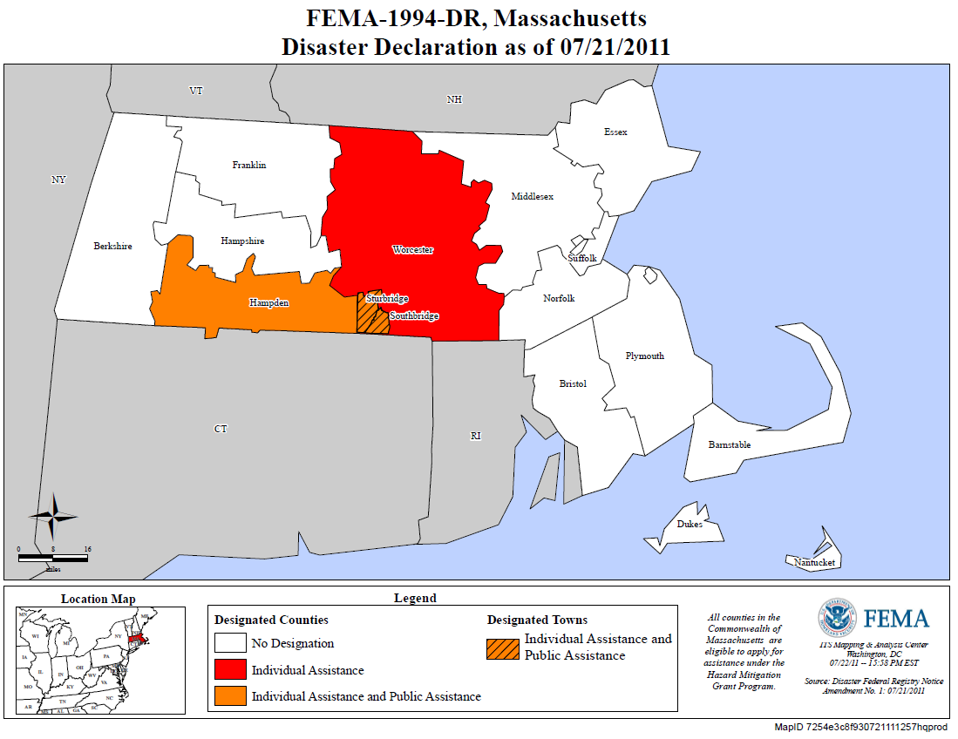

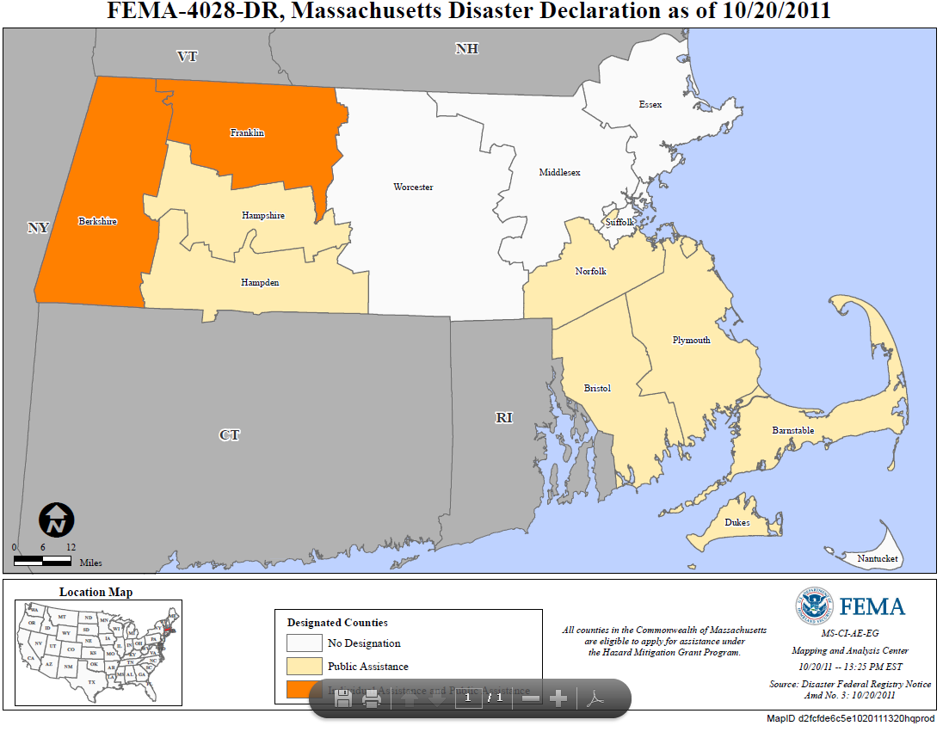

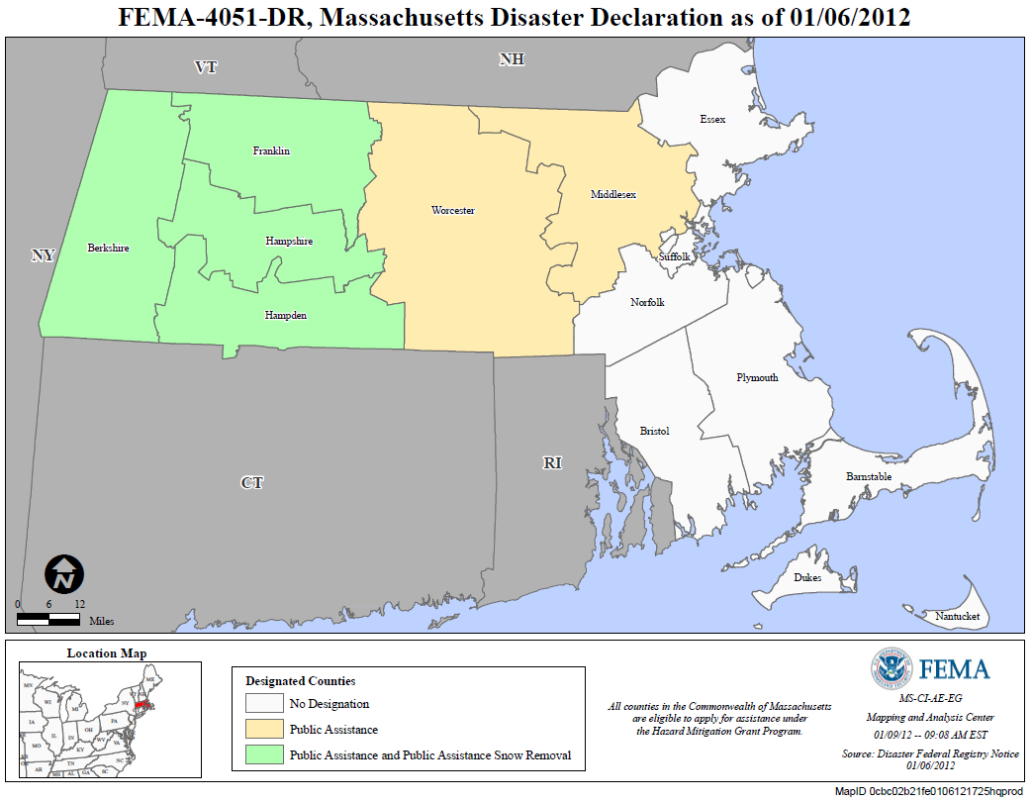

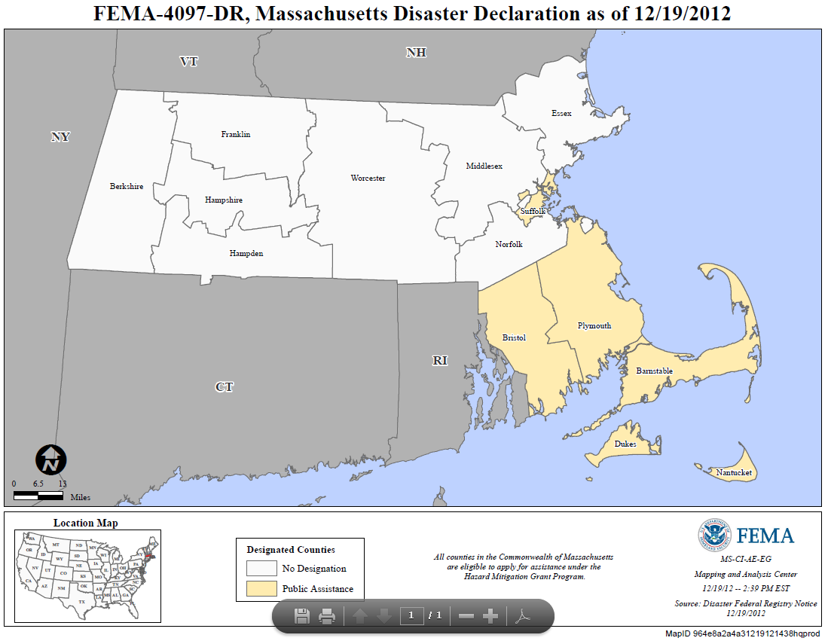

Appendix 4: Impact and Need Data by County

|  |  |  |  |  |  |  |  |  |  |
| --- | --- | --- | --- | --- | --- | --- | --- | --- | --- |
| **FEMA 1959: Public Assistance Preliminary Damage Estimates (all categories)** | | | | | |  |  |  |  |
| **Category** | **Berkshire** | **Essex** | **Hampden** | **Hampshire** | **Middlesex** | **Norfolk** | **Suffolk** | **Worcester** | **TOTALS** |
| A | $0 | $0 | $0 | $0 | $0 | $282,000 | $30,000 | $0 | $312,000 |
| B | $668,714 | $2,784,034 | $1,878,397 | $586,900 | $4,964,451 | $2,331,696 | $3,297,707 | $3,033,651 | $19,545,550 |
| C | $0 | $0 | $0 | $0 | $0 | $0 | $0 | $0 | $0 |
| D | $0 | $0 | $0 | $0 | $0 | $0 | $0 | $0 | $0 |
| E | $0 | $0 | $0 | $0 | $0 | $10,000 | $0 | $0 | $10,000 |
| F | $0 | $0 | $0 | $0 | $0 | $0 | $0 | $0 | $0 |
| G | $0 | $0 | $0 | $0 | $0 | $0 | $0 | $0 | $0 |
| **TOTALS** | **$668,714** | **$2,784,034** | **$1,878,397** | **$586,900** | **$4,964,451** | **$2,623,696** | **$3,327,707** | **$3,033,651** | **$19,867,550** |

|  |  |  |  |  |  |  |  |  |  |
| --- | --- | --- | --- | --- | --- | --- | --- | --- | --- |
| **FEMA 1959: Public Assistance Preliminary Damage Estimates (Permanent Work Only)** | | | | | | |  |  |  |
| **Category** | **Berkshire** | **Essex** | **Hampden** | **Hampshire** | **Middlesex** | **Norfolk** | **Suffolk** | **Worcester** | **TOTALS** |
| C | $0 | $0 | $0 | $0 | $0 | $0 | $0 | $0 | $0 |
| D | $0 | $0 | $0 | $0 | $0 | $0 | $0 | $0 | $0 |
| E | $0 | $0 | $0 | $0 | $0 | $10,000 | $0 | $0 | $10,000 |
| F | $0 | $0 | $0 | $0 | $0 | $0 | $0 | $0 | $0 |
| G | $0 | $0 | $0 | $0 | $0 | $0 | $0 | $0 | $0 |
| **TOTALS** | **$0** | **$0** | **$0** | **$0** | **$0** | **$10,000** | **$0** | **$0** | **$10,000** |

|  |  |  |  |
| --- | --- | --- | --- |
| **FEMA 1994 Public Assistance Preliminary Damage Estimates (all categories)** | | | |
| **Category** | **Hampden** | **Worcester** | **TOTALS** |
| A | $8,396,615 | $397,670 | $8,794,285 |
| B | $5,143,552 | $167,766 | $5,311,318 |
| C | $85,000 | $28,105 | $113,105 |
| D | $48,051 | $0 | $48,051 |
| E | $10,006,500 | $15,770 | $10,022,270 |
| F | $257,124 | $4,000 | $261,124 |
| G | $58,618 | $0 | $58,618 |
| **TOTALS** | **$23,995,460** | **$613,311** | **$24,608,771** |

|  |  |  |  |
| --- | --- | --- | --- |
| **FEMA 4028 Public Assistance Preliminary Damage Estimates (all categories)** | | | |
| **Category** | **Berkshire** | **Franklin** | **TOTALS** |
| A | $0 | $2,836,400 | $2,836,400 |
| B | $150,000 | $1,030,100 | $1,180,100 |
| C | $2,119,000 | $7,850,677 | $9,969,677 |
| D | $0 | $9,026,500 | $9,026,500 |
| E | $0 | $0 | $0 |
| F | $0 | $2,037,400 | $2,037,400 |
| G | $0 | $35,000 | $35,000 |
| **TOTALS** | **$2,269,000** | **$22,816,077** | **$25,085,077** |

|  |  |  |  |
| --- | --- | --- | --- |
| **FEMA 1994 Public Assistance Preliminary Damage Estimates (Permanent Work Only)** | | | |
| **Category** | **Hampden** | **Worcester** | **TOTALS** |
| C | $85,000 | $28,105 | $113,105 |
| D | $48,051 | $0 | $48,051 |
| E | $10,006,500 | $15,770 | $10,022,270 |
| F | $257,124 | $4,000 | $261,124 |
| G | $58,618 | $0 | $58,618 |
| **TOTALS** | **$10,455,293** | **$47,875** | **$10,503,168** |

|  |  |  |  |
| --- | --- | --- | --- |
| **FEMA 4028 Public Assistance Preliminary Damage Estimates (Permanent Work Only)** | | | |
| **Category** | **Berkshire** | **Franklin** | **TOTALS** |
| C | $2,119,000 | $7,850,677 | $9,969,677 |
| D | $0 | $9,026,500 | $9,026,500 |
| E | $0 | $0 | $0 |
| F | $0 | $2,037,400 | $2,037,400 |
| G | $0 | $35,000 | $35,000 |
| **TOTALS** | **$2,119,000** | **$18,949,577** | **$21,068,577** |

|  |  |  |  |  |  |  |  |  |  |
| --- | --- | --- | --- | --- | --- | --- | --- | --- | --- |
| **FEMA 4051: Public Assistance Preliminary Damage Estimates (all categories)** | | | | | |  |  |  |  |
| **Category** | **Berkshire** | **Essex** | **Franklin** | **Hampden** | **Hampshire** | **Middlesex** | **Norfolk** | **Worcester** | **TOTALS** |
| A | $175,329 | $319,239 | $818,680 | $38,731,508 | $2,986,220 | $6,602,378 | $794,534 | $5,267,800 | $55,695,688 |
| B | $325,037 | $501,207 | $251,711 | $2,250,827 | $818,593 | $1,465,903 | $1,403,383 | $2,314,275 | $9,330,936 |
| C | $0 | $0 | $0 | $30,000 | $0 | $50,500 | $0 | $1,000 | $81,500 |
| D | $0 | $0 |  | $52,500 | $25,500 | $165,000 | $0 | $40,200 | $283,200 |
| E | $0 | $9,608 | $67,000 | $141,000 | $0 | $113,500 | $0 | $14,500 | $345,608 |
| F | $0 | $0 | $300 | $48,000 | $0 | $365,357 | $0 | $50,000 | $463,657 |
| G | $0 | $0 |  | $12,278,000 | $30,200 | $74,220 | $0 | $7,500 | $12,389,920 |
| **TOTALS** | **$500,366** | **$830,054** | **$1,137,691** | **$53,531,835** | **$3,860,513** | **$8,836,858** | **$2,197,917** | **$7,695,275** | **$78,590,509** |

|  |  |  |  |  |  |  |  |  |  |
| --- | --- | --- | --- | --- | --- | --- | --- | --- | --- |
| **FEMA 4051: Public Assistance Preliminary Damage Estimates (Permanent Work Only)** | | | | | | |  |  |  |
| **Category** | **Berkshire** | **Essex** | **Franklin** | **Hampden** | **Hampshire** | **Middlesex** | **Norfolk** | **Worcester** | **TOTALS** |
| C | $0 | $0 | $0 | $30,000 | $0 | $50,500 | $0 | $1,000 | $81,500 |
| D | $0 | $0 |  | $52,500 | $25,500 | $165,000 | $0 | $40,200 | $283,200 |
| E | $0 | $9,608 | $67,000 | $141,000 | $0 | $113,500 | $0 | $14,500 | $345,608 |
| F | $0 | $0 | $300 | $48,000 | $0 | $365,357 | $0 | $50,000 | $463,657 |
| G | $0 | $0 |  | $12,278,000 | $30,200 | $74,220 | $0 | $7,500 | $12,389,920 |
| **TOTALS** | **$0** | **$9,608** | **$67,300** | **$12,549,500** | **$55,700** | **$768,577** | **$0** | **$113,200** | **$13,563,885** |

|  |  |  |  |  |  |  |  |
| --- | --- | --- | --- | --- | --- | --- | --- |
| **FEMA 4097: Public Assistance Preliminary Damage Estimates (all categories)** | | | | | |  |  |
| **Category** | **Barnstable** | **Bristol** | **Dukes** | **Nantucket** | **Plymouth** | **Suffolk** | **TOTALS** |
| A | $319,533 | $772,440 | $317,250 | $2,136 | $458,780 | $227,326 | $2,097,465 |
| B | $237,199 | $690,589 | $114,900 | $30,581 | $528,124 | $650,936 | $2,252,329 |
| C | $103,000 | $47,691 | $1,000 | $10,000 | $27,000 | $1,772 | $190,463 |
| D | $137,105 | $6,349 | $0 | $0 | $289,717 | $0 | $433,171 |
| E | $90,545 | $118,690 | $0 | $0 | $214,546 | $5,793,000 | $6,216,781 |
| F | $105,789 | $564,133 | $30,000 | $0 | $135,067 | $25,000 | $859,989 |
| G | $179,500 | $30,123 | $9,723,342 | $127,000 | $72,135 | $27,000 | $10,159,100 |
| **TOTALS** | **$1,172,671** | **$2,230,015** | **$10,186,492** | **$169,717** | **$1,725,369** | **$6,725,034** | **$22,209,298** |

|  |  |  |  |  |  |  |  |
| --- | --- | --- | --- | --- | --- | --- | --- |
| **FEMA 4097: Public Assistance Preliminary Damage Estimates (Permanent Work Only)** | | | | | | |  |
| **Category** | **Barnstable** | **Bristol** | **Dukes** | **Nantucket** | **Plymouth** | **Suffolk** | **TOTALS** |
| C | $103,000 | $47,691 | $1,000 | $10,000 | $27,000 | $1,772 | $190,463 |
| D | $137,105 | $6,349 | $0 | $0 | $289,717 | $0 | $433,171 |
| E | $90,545 | $118,690 | $0 | $0 | $214,546 | $5,793,000 | $6,216,781 |
| F | $105,789 | $564,133 | $30,000 | $0 | $135,067 | $25,000 | $859,989 |
| G | $179,500 | $30,123 | $9,723,342 | $127,000 | $72,135 | $27,000 | $10,159,100 |
| **TOTALS** | **$615,939** | **$766,986** | **$9,754,342** | **$137,000** | **$738,465** | **$5,846,772** | **$17,859,504** |

Appendix 5: Request for Letters of Interest

Commonwealth of Massachusetts

Department of Housing &

Community Development

Deval L. Patrick, Governor ◆ Aaron Gornstein, Undersecretary

Massachusetts Seal.

DHCD logo.100 Cambridge Street, Suite 300 www.mass.gov/dhcd

Boston, Massachusetts 02114 617.573.1100xxx

DATE: August 2, 2013

TO: All Interested Parties in Massachusetts

FROM: Massachusetts Community Development Block Grant Program

RE: **Funding Opportunity: Community Development Block Grant-Disaster Recovery (CDBG-DR) funds**

The Massachusetts Department of Housing and Community Development (DHCD) is eligible to receive and will be applying for $7,210,000 in CDBG-DR funding from the US Department of Housing and Urban Development (HUD). CDBG-DR funds may be used only for specific disaster recovery-related purposes (see below). Recovery efforts may involve housing, infrastructure and prevention of further damage to affected areas. The use of CDBG-DR funds may not duplicate funding available from the Federal Emergency Management Agency, the Small Business Administration, and the US Army Corps of Engineers.

Project/activity examples include:

* Constructing or rehabilitating public facilities such as streets, and water, sewer and drainage systems, government buildings, and neighborhood centers;
* Rehabilitation of homes and buildings damaged by the disaster;
* Purchase of damaged properties in a flood plain and relocating residents to safer areas;
* Homeownership activities such as down payment assistance, interest rate subsidies and loan guarantees for disaster victims;
* Economic development activities;
* Public services (generally limited to no more than 15 percent of the grant); and
* General administration costs (limited to no more than five (5) percent of the grant)

Eligible activities must meet at least one of three program national objectives: benefit to persons of low- and moderate- income, aid in the prevention or elimination of slums or blight, or meet other urgent community development needs.

Projects/activities must be undertaken in compliance with all applicable Federal and State rules and regulations including, but not limited to environmental review, flood insurance requirements, Davis Bacon wage rates, and federal procurement standards. All housing rehabilitation, reconstruction and new construction should be designed to incorporate principles of sustainability. At a minimum, HUD requires grantees to meet the Green Building Standard for Replacement and New Construction of Residential Housing.

DHCD will use information collected from state and federal agencies, public forums and community site visits to identify current and future projects and activities fundable under the CDBG-DR program. In addition, DHCD is requesting letters of interest from cities and towns describing local and regional disaster recovery projects or activities. All proposed projects must be in response to the following Disaster Declarations.

|  |
| --- |
| * FEMA Disaster 1959: Severe Winter Storm 1/11/11 – 1/12/11 (Berkshire, Essex, Hampden, Hampshire, Middlesex, Norfolk & Suffolk Counties) |
| * FEMA Disaster 1994: Tornado 6/1/11 (Hampden & Worcester Counties) |
| * FEMA Disaster 4028: Tropical Storm Irene 8/27/11 – 8/29/11 (Barnstable, Berkshire, Bristol, Dukes, Franklin, Hampden, Hampshire, Norfolk & Plymouth Counties) |
| * FEMA Disaster 4051: Severe Winter Storm 10/29/11 – 10/30/11 (Berkshire, Franklin, Hampshire, Hampden, Middlesex & Worcester Counties) |
| * FEMA Disaster 4097: Hurricane Sandy 10/27/12 – 11/8/12 (Barnstable, Bristol, Dukes, Nantucket, Plymouth & Suffolk Counties) |

HUD has further determined that a minimum of $1,388,800 must be provided to Hampden County. To ensure timely expenditure of funds, all funding must be expended within two years of the date HUD obligates the funds to the grantee (DHCD). At least 50% of DHCD’s funding must directly benefit low and moderate income individuals. Funds must be used to support projects that directly address the impacts of the Presidentially- Declared Disasters listed above.

**DHCD is requesting letters of interest from cities and towns for potential CDBG-Disaster Recovery projects/ activities by August 20th, 2013.** Eligible projects/activities will be considered for inclusion in an Action Plan being developed by the Department. Submission of a letter of interest does not guarantee funding. Communities that are unable to submit a letter of interest by August 20th may have the opportunity to submit information at a later date. The Action Plan will outline the initial proposed uses of the CDBG-DR funds and the methodology for selecting additional, future projects. The Action Plan will be posted for public comment and submitted to HUD for its approval. DHCD may amend the Action Plan to include additional projects and activities at a later date.

More information on eligibility requirements may be found at: <http://www.mass.gov/hed/community/funding/community-development-block-grant-disaster-recovery-.html>

**DHCD will hold an information session regarding the CDBG-DR program at 1:00 pm on Tuesday, August 13, 2013 at Union Station in Worcester, MA. Please see the attached map and directions.**

Please contact Mark Siegenthaler, Community Development Manager ([mark.siegenthaler@state.ma.us](mailto:mark.siegenthaler@state.ma.us) or 617-573-1426) or Patricia Roushanaei, Senior Program Representative ([patricia.roushanaei@state.ma.us](mailto:patricia.roushanaei@state.ma.us) or 617-573-1427) for further CDBG-DR Program information.

-------------------------------------------------------------

**Interested parties should email a letter of interest by August 20th, 2013, including the following required information, to Mark Siegenthaler at** [**mark.siegenthaler@state.ma.us**](mailto:mark.siegenthaler@state.ma.us)**.**

Applicant Name/Contact Information (including name, title, email address and telephone number):

Project/Activity Name, Community, County and Physical Address:

Project or Activity Description:

How does the project directly address the impacts of Presidentially Declared Disaster(s) in Massachusetts? Which Declaration is addressed? What unmet need is being addressed?

Project’s ability to benefit persons of low- and moderate- income, aid in the prevention or elimination of slums or blight, or meet other urgent community needs:

Project Budget (identify all sources & uses including known & expected match):

Project Timeline (identify expected start, project implementation, completion date – within 18 months – and any potential impacts to the timeline):

Applicant involvement in disaster recovery efforts to-date:

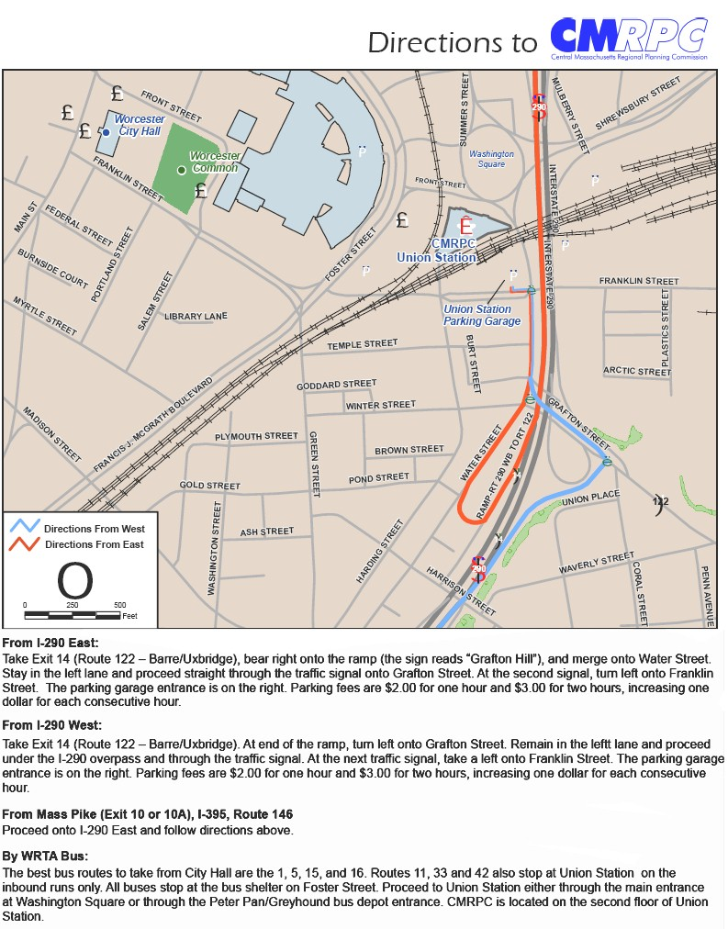

Appendix 6: Submitted Projects List

|  |  |  |  |  |  |  |  |
| --- | --- | --- | --- | --- | --- | --- | --- |
|  | **DHCD CDBG-DR Program** | |  |  |  |  |  |
|  | **Municipality** | **County** | **Project Name** | **Type** | **National Objective** | **Budget Estimate** | **Comments** |
|  |  |  |  |  |  |  |  |
| 1 | Adams | Berkshire | Charles Street Bridge | Public Facilities | LMI | $250,000 | Category 1 |
| 2 | Ashfield | Franklin | Smith Branch Road reconstruction | Public Facilities | Urgent Need | $375,000 | Category 1 |
|  |  |  | Regional Housing Rehabilitation Program | Housing | LMI/Urgent Need | $588,000 | Category 2 |
| 3 | Becket | Berkshire | Walker Brook culverts | Public Facilities | Urgent Need | $133,125 |  |
| 4 | Brookfield | Worcester | Stump removal, trimming |  |  | $125,000 |  |
| 5 | Buckland | Franklin | Bridge rehabilitation | Public Facilities | Urgent Need | $600,000 | Category 1 |
| 6 | Colrain | Berkshire | Town Highway Garage | Public Facilities | LMI | $1,000,000 | Category 3 |
| 7 | Fairhaven | Bristol | Union Wharf Building | Public Facilities | Slums & Blight | $150,000 | Category 1 |
| 8 | Hubbardston | Worcester | Housing Rehabilitation Program | Housing | LMI/Urgent Need | $330,000 | Category 2 |
| 9 | Nantucket | Nantucket | Baker Road Relocation | Public Facilities | Urgent Need | $11,000,000 |  |
| 10 | Northbridge | Worcester | Rockdale Youth Center | Public Facilities |  | $613,654 | Category 1 |
| 11 | Norton | Bristol | Housing Authority - Woodlands Meadows drainage | Public Facilities | LMI | $100,000 | Category 2 |
| 12 | Quincy | Plymouth | Parkhurst Marsh stormwater | Public Facilities |  | $260,000 |  |
| 13 |  |  | Grossman | Public Facilities | LMI | $969,000 |  |
| 14 | Rockland | Plymouth | Housing Rehabilitation | Housing |  | $341,575 | Category 2 |
| 15 |  |  | Community Center | Public Facilities |  | $286,100 |  |
| 16 | Savoy | Berkshire | Black Brook Rd. design | Public Facilities design | Urgent Need | $175,000 | Category 1 |
| 17 | Sturbridge | Worcester | Champeaux Road | Public Facilities |  | $1,437,500 |  |
| 18 |  |  | Walker Pond | Public Facilities |  | $2,333,392 |  |
| 19 | Templeton | Worcester | Housing Authority - Phoenix Court siding | Housing | LMI | $375,000 |  |
| 20 | Ware | Hampshire | WWTF generator | Public Facilities | LMI | $200,000 |  |
| 21 | Washington | Berkshire | Eden Glen Bridge | Public Facilities | Urgent Need | $130,000 |  |
| 22 | Webster | Worcester | Housing rehabilitation | Housing |  | $341,575 | Category 2 |
| 23 |  |  | Fire Station roof | Public Facilities |  | $199,725 |  |
| 24 |  |  | Burying Overhead Utilities | Public Facilities |  | $345,000 |  |
| 25 | Williamstown | Berkshire | Southworth St. extension | Public facilities | LMI | $315,000 | Category 1 |
|  |  |  |  |  |  |  |  |
|  | **Total Requested** | **$22,973,646** | **Total available** | **$5,821,200** |  |  |  |
|  |  |  |  |  |  |  |  |
| 1 | Chester | Hampden | Hampden Street water main replacement | Public Facilities | LMI | $302,085 | Category 1 |
| 2 | Chicopee | Hampden | Chicopee tree management | Public Facilities |  | $120,225 |  |
| 3 | Holland | Hampden | Over the Top Road drainage | Public Facilities |  | $60,000 | Category 3 |
| 4 | Monson | Hampden | Regional Housing Rehabilitation Program w/Brimfield, Wilbraham | Housing | LMI/Urgent Need | $540,000 | Category 2 |
| 5 |  |  | Park Road Drainage Project | Public Facilities | Urgent Need | $120,000 | Category 1 |
| 6 | West Springfield | Hampden | Union Street Park | Public Facilities | LMI | $1,000,000 | Category 1 |
|  |  |  |  |  |  |  |  |
|  | **Total Requested** | **$2,142,310** | **Minimum available** | **$1,388,800** |  |  |  |
|  | **Total Requested** | **$25,115,956** | **Total available** | **$7,210,000** |  |  |  |

Appendix 7: Proposed Project Activity Descriptions

**Grantee/Responsible Entity: Town of Adams**

Activity Title: Charles Street Bridge Reconstruction

Activity Type: Infrastructure Repairs

National Objective: Area-Wide LMI Benefit (Town of Adams is 57.8% LMI)

Budget: $250,000

Disaster, Impact and Unmet Need: The Charles Street Bridge was destroyed during FEMA Disaster 4028: Tropical Storm Irene. Since that time, the neighborhood formerly served by this bridge is now limited to a single point of access by crossing the Southwick Brook over a culvert. The neighborhood is a horseshoe-shaped configuration that formerly had two means of access.

Activity Description: Removal and reconstruction of the destroyed Charles Street Bridge. Once funding is received, the Town will develop bid-ready construction plans and specifications and construction would begin in Spring, 2014.

Proposed Accomplishments/Performance Measures: Improvements to one, (1) public facility.

------------------------------------------------------------------------------------------------------------------------------------------

**Grantee/Responsible Entity: Town of Ashfield & Franklin County Regional**

Activity Title: Smith Branch Road Reconstruction Project – Smith Road, Ashfield, MA

Activity Type: Infrastructure Repairs

National Objective: Urgent Need

Budget: $375,000

Disaster, Impact and Unmet Need: As result of FEMA Disaster 4028: Tropical Storm Irene and worsened by FEMA Disaster 4051: Severe Winter Storm, 2,718 linear feet of Smith Branch Road was washed out. The road’s washed-out condition makes it impassible and its condition worsens significantly with each subsequent storm. This road is the last road in Ashfield yet to be repaired as a result of these two storm events.

Activity Description: Engineering, removal of remnants of a former retention wall, construction of a new retention wall, and gravel resurfacing. Once funding is received, the town will commence the engineering and permitting activities on this project immediately. The bulk of the construction activity would be started at the beginning of the 2014 construction season (weather permitting) and would be completed by September of 2014.

Proposed Accomplishments/Performance Measures: Reconstruction of 2, 718 linear feet of roadway.

------------------------------------------------------------------------------------------------------------------------------------------

**Grantee/Responsible Entity: Town of Brimfield**

Activity Title: **Hollowbrook Farm, LLC Microenterprise Assistance/Housing**

Activity Type: Microenterprise Assistance/Housing

National Objective: LMI Benefit

Budget: up to $236,500

Disaster, Impact and Unmet Need: The Hollowbrook Farm, LLC located on Hollow Road, Brimfield, has been unable to operate since sustaining extensive damage from FEMA disaster 1994 (June, 2011 tornado).  Before the tornado, the business owner operated a cut-your-own Christmas tree farm, a retail store, and provided horse-drawn carriage and sled rides over a system of trails and fields on the farm property for many years. The tornado caused extensive damage to the barn which included a housing unit, and much equipment related to the operation was lost.  Additionally, the field and trail system were completely covered in debris from the tornado, and to this day they remain impassable.  The carriage/sleigh ride operation has been unable to continue since the 2011 tornado due to the substantial losses and dangerousness of the property.  The barn also had an apartment on the second floor, which was destroyed in the tornado.

Activity Description: Up to $236,500 will be awarded to the Town of Brimfield. A budget of $100,000 will fund an economic development project and $125,000 will fund housing rehabilitation.  The project will allow the owner to repair the barn, clean-up the fields and trails, and replace lost equipment necessary to operate the business. The project will also allow for rehabilitation of a housing unit to bring it into code compliance.

Proposed Accomplishments/Performance Measures: Assistance to a micro enterprise to allow it to continue operations and the rehabilitation of a housing unit.

**Grantee/Responsible Entity: Town of Buckland**

Activity Title: Clesson Brook Rd. Bridge Rehabilitation

Activity Type: Public Facilities

National Objective: Urgent Need

Budget: $600,000 (original) revised to $850,000 (an additional $250,000 via August Action Plan Amendment)

Disaster, Impact and Unmet Need:

The Clesson Brook Road Bridge was completely covered in debris following Tropical Storm Irene (FEMA Disaster 4028). Prior to clean up of the debris, it was thought that the bridge had been washed away. This bridge serves is the major access route to a largely developed area in upper Buckland; the only other access to this area is via two narrow, winding country roads that are unable to accommodate safety equipment such as fire truck and ambulances. Clesson Brook Road connects the residents of Hawley and Buckland to Route 112; when the bridge is impassible, the Buckland Fire District must rely on emergency services from the Town of Hawley to service the area.

Activity Description:

Rehabilitation of the 35-foot long, 25-foot 9-inch wide steel stringer/girder bridge will include repair of spalled and deteriorated areas of the underside of the concrete deck and fascia; installation of a water proofing membrane on the top surface of the bridge deck and bituminous overlay of the bridge deck; cleaning, rust removal and repainting of the steel beams and bearings; and removal and rebuilding of the southeast abutment and southeast wingwall.

Proposed Accomplishments/Performance Measures: Rehabilitation of 35 linear foot bridge

-----------------------------------------------------------------------------------------------------------------------------------------

**Grantee/Responsible Entity: Town of Chester**

Activity Title: Hampden Street Water Main Restoration Project

Activity Type: Public Facilities

National Objective: Low-and Moderate Income area benefit

Budget: $302,085

Disaster, Impact and Unmet Need:

Tropical storm Irene damaged the water main located under Walker Brook at the Hamden Street Bridge intersection. Its subsequent removal from services is attributed in its entirety to FEMA Disaster 4028. The disconnection of this section of the water line has allowed the Town’s water system to continue to operate, but has eliminated an important loop in the distribution system and is not a long-term solution to address the damage sustained in the storm.

Activity Description:

Installation of a new water main to replace an existing water line removed from service due to damage sustained during Tropical Storm Irene. The existing line, installed under Walker Brook, will be abandoned in place, reducing the construction and environmental impact on the project area. The new water main will cross *over* the Brook on a support beam adjacent to the Hampden Street Bridge. This support beam and pipe will be installed at the east side of the bridge, minimizing the threat of damage due to another high-water event.

Proposed Accomplishments/Performance Measures:

Installation of 100 linear feet of new 8” ductile iron water main

------------------------------------------------------------------------------------------------------------------------------------------

**Grantee/Responsible Entity: Town of Colrain**

Activity Title: Town Highway Garage

Activity Type: Rehabilitation

National Objective: Low-and Moderate Income area benefit

Budget: $997,500 including grant administration

Disaster, Impact and Unmet Need: Colrain’s municipal highway garage sustained severe damage during FEMA Disaster 4028: Tropical Storm Irene. The facility was significantly flooded damaging the structure, its foundation and building systems.

Activity Description: The Town has commissioned an engineering review of the building to assess effective rehabilitation activities to return the building to full use and protect it from future storm events.

Proposed Accomplishments/Performance Measures: Rehabilitation of a public facility serving a community that is comprised of over 51% low and moderate income residents.

-------------------------------------------------------------------------------------------------------------------------------

**Grantee/Responsible Entity: Town of Fairhaven**

Activity Title: McLean’s Seafood Building at Union Wharf

Activity Type: Demolition

National Objective: Area Wide Slums & Blight (DHCD-approved S&B Target Area)

Budget: $150,000 (original) revised to $318,870 (via December 2014 Action Plan Amendment)

Disaster, Impact and Unmet Need: McLean’s Seafood Building at Union Wharf sustained severe damage during FEMA Disaster 4028: Tropical Storm Irene. A portion of the wall was blown out exposing the building to the elements and affecting the structural integrity of that portion of the wall. The Town, as a stop gap measure, had a 2’x6’ patch wall installed to make the building somewhat more weather tight and keep the second floor in this section of the building from structurally failing. This repair was only a temporary solution.

Activity Description: The Town owns an approximate 5,400 SF, two-story building on the North side of Union Wharf. The building was once home to McLean’s Seafood, which was used as a seafood unloading and processing facility. The building is currently vacant and has not been used for over seven years. In 2007, the Town appropriated funds to demolish the eastern half of the building and install a fire alarm system in the remaining building. Since then the remaining building has deteriorated, including damage sustained during Tropical Storm Irene, to a point where rehabilitation is not an option.

Proposed Accomplishments/Performance Measures: Demolition of one, (1) blighted structure in a designed slum & blight area.

**Grantee/Responsible Entity: Town of Holland**

**Activity Title:** Over the Top Road - Drainage Repair

**Activity Type:** Infrastructure

**National Objective:** Urgent Need

**Budget:** $88,200 (original) revised to $157,075 (an additional $68,875 via August Action Plan Amendment)

**Disaster, Impact, and Unmet Need:** The impacts of both Severe Winter Storms (1/11/11-1/12/11 FEMA Disaster 1959, and 10/29/11-10/30/11 FEMA Disaster 4051) and Hurricane Irene (FEMA Disaster 4028) will be addressed. Due to the excessive amount of snow followed by the melting causing run off and erosion of Over the Top Road, and the heavy rains that were associated with the hurricane, caused a significant amount of the road to erode into residential properties and in to the Hamilton Reservoir. The unmet need that is being addressed is to effectively channel storm water to eliminate the damage to properties and sediment continuously being dumped into the reservoir by repairing the drainage and control erosion problems on Over the Top Road in Holland. Presently the rainwater and snowmelt continuously wash the gravel road of Over the Top Road into residential properties and into the Hamilton Reservoir.

**Activity Description:** Repair andaddress drainage, erosion and roadway to control storm water runoff into the Hamilton Reservoir. Hamilton Reservoir is a public waterway utilized by the community year round and there has been growing concerns for the amount to sediment that has been flowing into the waterway. Conversations of dredging the lake have occurred, but the potential impacts of dredging have dissuaded any further action from being taken

**Proposed Accomplishments/Performance Measures**: Drainage and Erosion Control measures and Reconstruction of roadway

**Grantee/Responsible Entity: Town of Monson**

Activity Title: Park Road Drainage Improvement Project

Activity Type: Public Facilities

National Objective: Urgent Need - Existing conditions of the drainage system pose a serious and immediate threat to the health and welfare of Monson due to erosion of the slope.

Budget: $120,000 (original) revised to $0 (via August 2015 Action Plan Amendment)

Disaster, Impact and Unmet Need: This project directly addresses an impact of a presidentially declared disaster in Massachusetts, as the proposed Park Road Drainage Improvement Project will provide reconstruct a drainage channel that was directly affected by the June 1, 2011 Tornado (FEMA Disaster 1994). This channel directs runoff from a large area that was deforested by the tornado.

The project reconstructs the roadside drainage channel along Park Road that was severely impacted by the increased run off due to the deforestation from the tornado of the upland areas. The project proposes to reconstruct 800 feet of drainage channel south from High Street to the Flynt Park entrance. Presently, the channel is earth and rock with unstable banks. In some sections the channel is three feet below the elevation of the roadway edge. The project stabilizes and improves the undercut slopes of an open drainage system

Activity Description:

The existing drainage channel will be reconstructed as a paved water way to convey storm water runoff to the existing discharge at High Street. The reconstruction will consist of filling and shaping the channel to a consistent cross section and placing a 7 foot wide, 2 ½ inch thick hot asphalt mix for the finished water way adjacent to the roadway. The side slope outside of the pavement will be stabilized at a maximum 2 to 1 slope with loam, seed and mulch. Where the opportunities exist, the former channel area will be graded nearly level and finished with loam, seed and mulch. Stilling pools will be created at the major inflow locations along the drainage channel to facilitate the collection of the water inflows.

The project also proposes to repave Park Road once the drainage work is complete.

Proposed Accomplishments/Performance Measures: reconstruct a fully designed, engineered, and permitted drainage channel damaged by the increase runoff due to the deforestation resulting from the tornado.

------------------------------------------------------------------------------------------------------------------------------------------

**Grantee/Responsible Entity: Town of Northbridge and Central MA Regional Planning Commission**

Activity Title: Rockdale Youth Center Relocation Project

Activity Type: Acquisition/Flood Buyout, Demolition, Rehabilitation

National Objective: Urgent Need

Budget: $601,654 (original) revised to $861,554 (via December 2014 Action Plan Amendment) revised to $1,620,255 (an additional $758,701 via August 2015 Action Plan Amendment)

Disaster, Impact and Unmet Need: The Rockdale Youth Center (RYC) building, owned and operated by the Whitin Community Center, is located in a 100-year flood plain and suffered extensive structural/water damage beyond their capability to repair as a direct result of the following storms: FEMA Disasters 1994 and 4051. The impact of previous flood events (DR-1994) led to flood damage, but the October Snowstorm (FEMA Disaster 4051) severely compromised the building’s structure. The roof was damaged and ice dams formed which created leaks into the buildings walls and interior. Most of the costs associated with the damage were not covered by insurance. FEMA Disaster 4051 also resulted in the stockpiling of snow along the side of the building and salt laden snow sat against the building for weeks causing damage to the foundation and siding. As the snow melted, additional flooding occurred. In addition, the building suffered damage to the lower siding slats and wood sole plates where the wall support studs attach.

During FEMA Disaster DR-1994, high winds and rain caused water to leak through the roof causing damage to interior ceiling and insulation. Additionally, due to the facility’s location, storm water runoff flowed up against the building and into the crawl space, exacerbating existing damages caused by previous disasters and flood events. During this disaster, heavy rains caused the Blackstone River to rise and back up against the building. This caused additional flooding of crawl space area and damage to the structure.

Activity Description: The RYC has determined that it is not economically feasible to flood proof the existing facility by elevating it above base flood elevation (approximately five feet), maintain its structural integrity, and remain ADA compliant. The total cost of reconstructing the existing building in its current location is estimated to be $270,000: however, the building would still be threatened by flooding and high water events. CDBG-DR funding will be used for the acquisition/flood buyout and demolition of the property on Providence Street and the rehabilitation of a former Catholic school owned by the St. Peter’s Parish that will be used to relocate the RYC. The building, which has been vacant for 15 years, is structurally sound but will require significant renovations and upgrades so that the RYC may move its programs there.

Proposed Accomplishments/Performance Measures: Demolition of one, (1) blighted structure and rehabilitation of a public facility for use as a Youth Center.

-------------------------------------------------------------------------------------------------------------------------------

**Grantee/Responsible Entity: Town of Norton**

Activity Title: Woodland Meadow Housing Authority

Activity Type: Housing

National Objective: LMI Benefit

Budget: $570,675 revised to $671,002 (an additional $100,327 via August 2015 Action Plan Amendment)

Disaster, Impact and Unmet Need: Hurricane Sandy (FEMA Disaster 4097) caused land erosion that impedes drainage and has resulted in the septic system being over-taxed by additional water seeping into the lift stations and being distributed into the leeching fields. The design of the leeching field did not include the current level of storm water drainage which has increase as a result of damage caused by Hurricane Sandy. In addition the erosion has also resulted in water collection in the basements of the buildings.

Activity Description: Funds would be used to correct erosion and drainage problems and replace the over taxed septic system by connecting the property to a waste water treatment plant.

Proposed Accomplishments/Performance Measures: Elimination of erosion issues and water collection in and around housing authority buildings, correcting a failing drainage system, assisting an over taxed septic system with a connection to a sewer treatment facility.

-------------------------------------------------------------------------------------------------------------------------------

**Grantee/Responsible Entity: Town of Savoy**

Activity Title: Black Brook Road Reconstruction

Activity Type: Public Facilities

National Objective: Urgent Need

Budget: $175,000

Disaster, Impact and Unmet Need: Tropical Storm Irene impacted Black Brook Road, which is a critical access road for mutual aid and emergency services for remote areas of Savoy. It provides vital access to RT 2, North Adams, Florida, Charlemont, Buckland, Greenfield and US 91. During the Summer of 2012, Savoy Highway Crew members spent the bulk of their time working to upgrade Black Brook Road and ready it for paving, including new drains and guardrails. Then Irene hit, devastating the road just as connecting RT 2 experienced.

Activity Description: Design costs for Black Brook Road which is a vital access road for mutual aid and emergency services for remote areas of Savoy.

Proposed Accomplishments/Performance Measures: Road engineering and design that will result in plans for road that may need to be moved in several places and which will affect overall design, permitting and cost. The town is looking for actual construction to be started in the late fall of 2013 to spring of 2014.

-------------------------------------------------------------------------------------------------------------------------------

**Grantee/Responsible Entity: Town of West Springfield**

Activity Title: Merrick Neighborhood Site Demolition, Remediation and Redevelopment Project

Activity Type: Public Facilities

National Objective: Low-and Moderate Income area benefit

Budget: $750,000 revised to $850,810 (an additional $100,810 via August 2015 Action Plan Amendment)

Disaster, Impact and Unmet Need:

The Merrick section of West Springfield was particularly hard-hit by the June 1, 2011, EF-3

Category tornado (FEMA Disaster Declaration 1994), and suffered two of the three storm related fatalities in western Massachusetts. The damage to the neighborhood dramatically changed conditions there. In particular, two business were partially destroyed by the tornado and as a result, unusable and contaminated sites remain. Redevelopment and recovery efforts are infeasible without assistance with assessment, demolition, and remediation of the sites allowing for future redevelopment.

Activity Description:

The proposed Project will involve municipal acquisition of one or both sites, demolition of the remaining buildings, remediation of the sites and restoration to buildable grades for future redevelopment by private parties.

Proposed Accomplishments/Performance Measures:

Funds will be used to cover the costs associated with the engineering assessment, acquisition, building demolition, and site remediation. Economic recovery of the area will be aided by the return of these sites to useful development, encouraging economic development opportunities.

-------------------------------------------------------------------------------------------------------------------------------

**Grantee/Responsible Entity: The Town of Williamstown**

Activity Title: Southworth Street infrastructure to new affordable housing site

Activity Type: Public Facilities

National Objective: Benefit low-moderate income persons

Budget: The Town of Williamstown is applying for $300,000 in project costs to complete the extension of Southworth Road to the affordable housing site and $15,000 in General Administration for a total request of $315,000.

Disaster, Impact and Unmet Need: Tropical Storm Irene destroyed 165 of the 225 mobile homes in The Spruces Manufactured Housing Community, displacing close to 300 people. The displaced individuals not only lost their homes, but also their ability to live independently in their home community. This loss of homes exacerbated an already serious shortage of affordable housing in Williamstown and created an urgent need for more housing for lower income households.

Activity Description: The CDGB-DR project will assist residents who were displaced by Tropical Storm Irene and those residents who will be displaced by the proposed removal of the remaining units in the flood prone park by facilitating the development of new affordable rental housing that will be available to them. Extending Southworth Street will provide vehicular and pedestrian access and public utilities to an approximately 4-acre site being donated by Williams College for the express purpose of creating housing that addresses the needs of those residents.

Proposed Accomplishments/Performance Measures: Funds will be used to extend Southworth Street to the affordable housing site and $15,000 in General Administration for a total request of $315,000. The CDBG-DR funds will leverage an estimated $12.3 million in additional funds that will be used for the development of the new housing. Anticipated sources include: Williamstown CPA grant, 9% Low Income Housing Tax Credits, State Subordinate Loans (HSF, AHTF, Home), FHLB AHP Grant and a Private 1st Mortgage.

Appendix 8: Public Notice of Action Plan Comment Period

**PUBLIC COMMENT PERIOD**

**Community Development Block Grant Disaster Recovery (CDBG-DR)**

**Action Plan**

The U.S. Department of Housing and Urban Development (HUD) has allocated to Massachusetts, $7.21 million from the Disaster Relief Appropriations Act of 2013 (P.L. 113-2) for distribution through the Massachusetts Community Development Block Grant (CDBG) Program. The funds are intended to address unmet housing, infrastructure and business needs in communities recovering from storms that received federal disaster designations in 2011 and 2012.

In accordance with CDBG-DR requirements, The Commonwealth is required to submit an Action Plan that identifies the proposed uses of the funding, including criteria or eligibility, and how the uses address long-term recovery needs. DHCD has posted the draft in order to provide opportunity for public comment. The draft CDBG-DR Action Plan is available on DHCD’s website, at [www.mass.gov/dhcd.](http://www.mass.gov/dhcd)

Interested parties should feel free to submit comments through August 30, 2013, in writing or via email, directly to DHCD. Comments may be directed to: Mark Siegenthaler, Community Development Manager, DHCD, 100 Cambridge St, Suite 300, Boston, MA 02114 or [mark.siegenthaler@state.ma.us](mailto:mark.siegenthaler@state.ma.us).

Comments Received

The Department received several clarification questions regarding individual letters of interest submitted from the same individual respondents.

The Department received several questions regarding the status of projects identified in letters of interest but not included in Category 1, 2 or 3.

Response to Comments

The Project Selection section of the Action Plan has been amended to provide greater detail and clarity regarding the status letters of interest for projects not listed in categories 1, 2 or 3.

Appendix 9: Program Income, Monitoring Standards and Detection of Fraud, Waste and Abuse

Program Income

DHCD-funded activities under CDBG-DR will not generate Program Income. Further, as provided in the CDBG-DR Certification documents:

9.

|  |  |  |  |  |  |  |  |
| --- | --- | --- | --- | --- | --- | --- | --- |
| a. If revenue-generating activities (e.g., rehabilitation, economic development loans) will be undertaken by the program participant, has the participant developed standards to track and disburse the program income (for an eligible use)? | |  |  |  | | --- | --- | --- | |  |  |  | | **Yes** | **No** | **N/A** | |
| **Provide Cross-Reference to Standards:**  Both CDBG/GMS and MMARS track program income | |

|  |  |  |  |  |  |  |  |
| --- | --- | --- | --- | --- | --- | --- | --- |
| b. Does the program participant have a system and standards for tracking program income generated by subrecipients or other entities to which funds are passed through?  [24 CFR 570.502(a)(4), 24 CFR 570.489(d)] | |  |  |  | | --- | --- | --- | |  |  |  | | **Yes** | **No** | **N/A** | |
| **Provide Cross-Reference to Standards:**  Same as above | |

|  |  |  |  |  |  |  |  |
| --- | --- | --- | --- | --- | --- | --- | --- |
| c. If program income will be retained by a subrecipient or pass-through entity, does the program participant have a system and standards for ensuring that such income is reported in a timely and accurate manner? | |  |  |  | | --- | --- | --- | |  |  |  | | **Yes** | **No** | **N/A** | |
| **Provide Cross-Reference to Standards:**  CDBG/GMS tracks program income in “real time” | |

|  |  |  |  |  |  |  |  |
| --- | --- | --- | --- | --- | --- | --- | --- |
| d. Upon expiration of any agreements between the program participant and a subrecipient and/or pass-through entity, does the participant have standards to ensure:   1. the timely and accurate transfer of any funds to be returned to the participant; and/or 2. the timely and accurate transfer of outstanding loans or accounts receivable? | |  |  |  | | --- | --- | --- | |  |  |  | | **Yes** | **No** | **N/A** | |
| **Provide Cross-Reference to Standards :**  CDBG/GMS grant close-out procedures;  sub-recipients continue to report program income in CDBG/GMS | |

10.

|  |
| --- |
| Does the program participant have standards that explain how it will comply with the requirements governing the receipt of, and reporting on the use of, program income in the DRGR System? (NOTE: program income, other than program income deposited in revolving funds, must be disbursed in payment of program costs prior to making further cash withdrawals.)  [24 CFR 570.502(a)(5), 24 CFR 570.504(b), 24 CFR 570.489(d)] |
| **Provide Cross-Reference to Standards:** |
| CDBG/GMS will identify sub-recipient program income. MA CDBG staff will enter program income amounts in DRGR. |

11.

|  |  |  |  |  |  |  |  |
| --- | --- | --- | --- | --- | --- | --- | --- |
| If the program participant will provide loans, does it have standards that describe how it will properly service all CDBG-assisted loans, including:  i. written loan agreements that clearly describe the repayment terms, what constitutes a default and how it can be cured, what actions the program participant will take if the default is not cured, and (if applicable) what is pledged as security for the loan?  ii. collection standards that provide for the recognition of all current amounts due, payments received, notification to borrower when payments are overdue, a process for taking further action on defaulted loans, and criteria for writing off bad debts?  [24 CFR 570.502(a)(4), 24 CFR 570.489(d)] | |  |  |  | | --- | --- | --- | |  |  |  | | **Yes** | **No** | **N/A** | |
| **Provide Cross-Reference to Standards:**  DHCD does not anticipate making loans under this program | |

Monitoring Standards

All DHCD CDBG-DR grantees will be monitored in accordance CDBG program requirements as outlined in DHCD’s CDBG/GMS online grant management system and DHCD’s CDBG Operations Manual.

Detection of Fraud, Waste and Abuse

As provided in the CDBG-DR Certification documents:

**VI. Procedures to** **Detect Fraud, Waste, and Abuse of Funds**

|  |  |  |
| --- | --- | --- |
|  | **Grantee** | **HUD** |
| 1. Has the grantee attached procedures that indicate how the grantee will verify the accuracy of information provided by applicants?   See Fraud, Waste and Abuse materials attached below | |  |  | | --- | --- | |  |  | | **Yes** | **No** | | |  |  | | --- | --- | |  |  | | **Yes** | **No** | |
| 1. Has the grantee provided a monitoring policy that indicates: 2. How and why monitoring is conducted, 3. The frequency of monitoring, and 4. Which items are monitored? | |  |  | | --- | --- | |  |  | |  |  | |  |  | | **Yes** | **No** | |  |  | | **Yes** | **No** | |  |  | | **Yes** | **No** | |  |  | |  |  | |  |  | |  |  | | |  |  | | --- | --- | |  |  | |  |  | |  |  | | **Yes** | **No** | |  |  | | **Yes** | **No** | |  |  | | **Yes** | **No** | |  |  | |  |  | |  |  | |  |  | |
| Has the grantee’s internal auditor affirmed and described its role in detecting fraud, waste, and abuse? DHCD’s Director of Internal Controls, Audits & Contracts, Mekdes Abebe, coordinates the Agency‘s internal training and policies regarding Fraud, Waste and Abuse.  Her position reports to the Undersecretary, separate from Chief Counsel and the CFO.  The State Auditors website has a reporting mechanism for suspected fraud.  The link is: <http://www.mass.gov/auditor/report-fraud-and-waste.html> | |  |  | | --- | --- | |  |  | | **Yes** | **No** | | |  |  | | --- | --- | |  |  | | **Yes** | **No** | |
| **Has the grantee met the above requirements? If no, explain.** | | |  |  | | --- | --- | |  |  | | **Yes** | **No** | |



